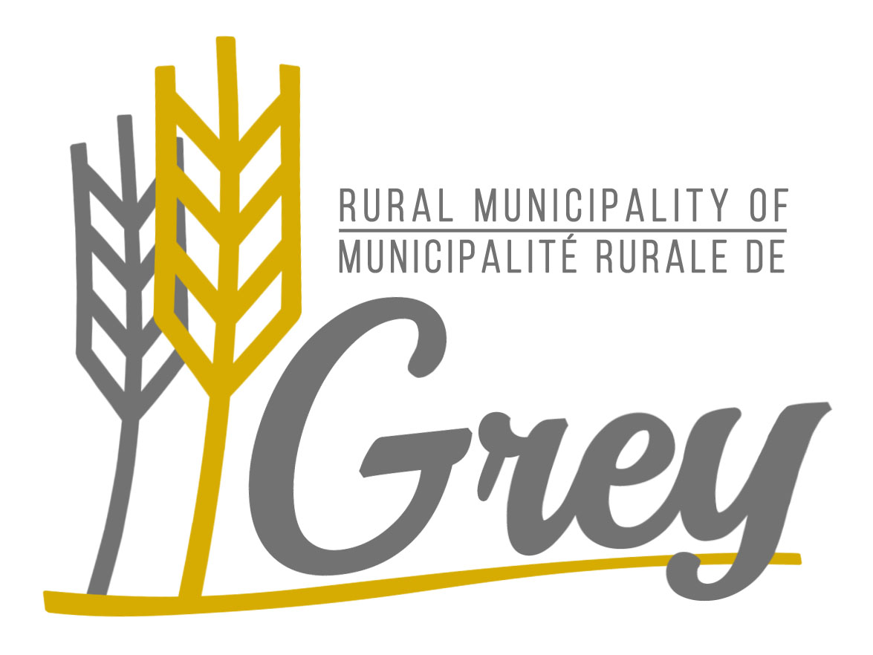

Accessibility Plan
for the Rural Municipality of Grey
for Jan, 1 2024 – Dec, 31 2024

Contact Person:
Jared Cummer, Accessibility Coordinator

Phone:
1-204-436-2014

Email:
safety@rmofgrey.ca

This document is available in a variety of accessible formats upon request. Contact the Accessibility Coordinator at the information provided above.
Contents

Statement of Commitment………….......................................................................3

Organizational Overview…....................................................................................3

Accessibility Plan...................................................................................................3

Accessible Customer Service................................................................................4

Accessible Employment.........................................................................................6

Statement of Commitment

The RM of Grey is committed to ensuring equal access and participation for people with disabilities. We are committed to treating people with disabilities in ways that allow them to maintain their dignity and independence. We believe in inclusion.

We are committed to meeting the needs of people who face accessibility barriers. We will do this by identifying, removing and preventing barriers and by meeting the requirements of The Accessibility for Manitobans Act.

On an ongoing basis, the RM of Grey will review all programs, services and new initiatives to ensure accessibility. The council for the RM of Grey will consider and incorporate accessibility requirements in their short and long term planning going forward.

Organizational Overview

The RM of Grey provides municipal services to approximately 2,517 residents within its boundaries and includes the communities of Fannystelle, Elm Creek, Haywood and St. Claude. Core services include water and wastewater, public works, fire services, recycling, waste disposal grounds and a municipal office. Garbage collection is tendered for two communities. The municipality is also involved in a number of parks, museums and recreation facilities.

The municipality is responsible for communication with residents about the programs and services it provides and responding to enquiries. As the municipality is a public entity, existing to serve all residents, the removal of accessibility barriers is an important consideration for the municipality.

Accessibility Plan

This Accessibility Plan is made available to the general public on the RM website, bulletin boards, and paper copies will be available at the municipal office.

An Accessibility Coordinator and Accessibility Committee are in place and will review and document specific accessibility situations that arise. Regular reporting to the Chief Administrative Officer and council regarding the RM of Grey's accessibility issues, challenges and successes will take place. The RM of Grey will review and update the plan every two years.

Accessible Customer Service

Achievements:

- Accessible Customer Service Policy has been created.
- The Municipal Office has automated doors, lever handles, is wheelchair accessible, has accessible washrooms, wide halls, wide office doors, the council chambers are at ground level and there are many seating options for persons with mobility issues.

- The Municipal office has also placed the Access Offer sign at the reception desks as well as accessibility signage to let residents know that we provide accessible services. We have also put in place a process to respond to residents’ requests for accessible supports and services and to respond to feedback and complaints.

- In the Municipal Office and Waste Disposal Ground we have dedicated staff available to greet, direct and offer the public assistance. The staff is empowered to accommodate all visitors. This includes physically writing out cheques and filling out forms on people’s behalf, explaining processes, enlarging documentation and physically assisting people.

- A variety of methods are used to communicate municipal services and programs to the public. This includes advertising in local newspapers, direct mail, handing posters in public areas within the municipality and on our website. There are multiple ways for general public to get into contact with employees.

- Public works department keeps the roads clear of snow following any significant snowfall. Sidewalks are cleared of snow prior to general business hours following any significant snowfall.

- Bilingual services are provided.

- Our municipal website ensures cross browser compatibility as well as compatibility with text readers for the visually impaired, there is also a mobile view which will ensure ease of use from mobile devices. Other items built into our website are alt tags/titles on images, simplified design, font resizer, tabbed navigation and fonts that are easy to read.

- RM of Grey staff has received Accessible Customer Service training.

- RM of Grey’s Connect program is now available to provide important emergency information in multiple methods of communication to customers.

- The RM of Grey will make information available in an accessible format or provide communication supports to people with disabilities in a way that considers their disability.
- An in-house Accessible Customer Service training plan has been developed for council, staff, and volunteers.
- An accessible spot for parking has been made available with the hope of breaking barriers.

Actions:

- Addressing barriers within our community with the help of all departments and the public.

Timeline: Ongoing

- Continue council, staff, and volunteer training in Accessible Customer Service.
Timeline: Ongoing

- Conduct annual audits of RM facilities to ensure accessibility barriers are identified and addressed, and signage with accessibility information be provided to these facilities.

Timeline: Ongoing

Accessible Employment

Achievements:

- Accessible Employment Policy has been created.
- Created a return-to-work policy to help employees with disabilities and health conditions to stay at work or return to work as soon as it is safe to do so.
- Accessible parking spot was installed in Spring 2022.
- All employees are up to date on accessibility training. 2022.
- Automated doors for Community Halls, curling rinks, arenas were installed Summer 2023. (Donated by the Rm of Grey Council).

Actions:

- Current employees to be invited to notify the RM about their accessibility needs during an emergency. Future employees will be asked at time of orientation.
Timeline: Ongoing

- Monitor anticipated Employment Standards and prepare for implementation and compliance
Timeline: Ongoing

- Job descriptions and postings will be reviewed as to not unreasonably exclude persons with disabilities from seeking opportunities for the RM.
Timeline: Ongoing

Accessibility Plan for the Rural Municipality of Grey
Dec, 31 2024 – Jan 1, 2025

Date of approval: __________________

Contact Person:
Jared Cummer, Accessibility Coordinator

Phone:
1-204-436-2014

Email:
safety@rmofgrey.ca

___________________________ ____________________________
Gail Johnson, Reeve Date:

___________________________ ____________________________
Kim Arnal, CAO Date:

