MUNICIPALITY OF McCREARY
432 First Avenue, Box 338, McCreary, Manitoba R0J 1B0
Ph: 204-835-2309 Fax: 204-835-2649
Email: municipality@mccreary.ca

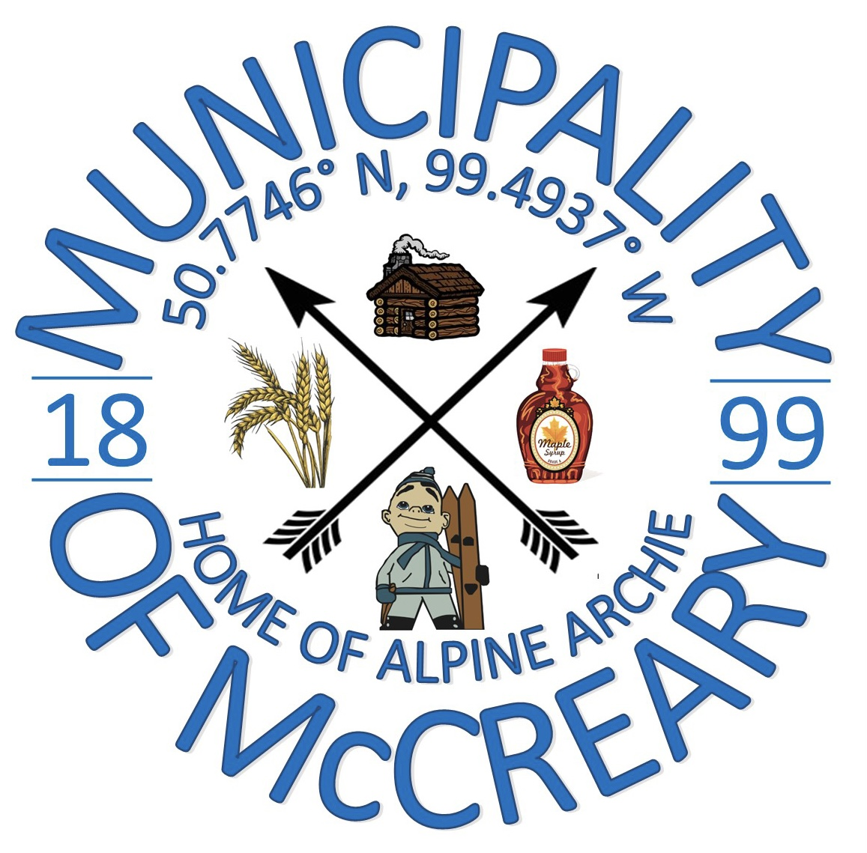

Title: Sale of Municipal Owned Agricultural Lands Policy
Resolution No. 15-2024 Date: January 16, 2024
Purpose:
The purpose of this policy is to outline the practices and procedures to follow when selling Municipal Owned Agricultural Land.

Policy:

- a Lessee may submit an “Offer to Purchase” by way of application if they hold the lease on that parcel;
- land shall be sold at the assessed value, plus 50% (plus land transfer fees, legal fees and any other fees associated with the cost of the land transfer);
- an “Offer to Purchase Application” is to be filled out and accompanied by a deposit in the amount of 10% of the set price in order to start the sale process;
- balance of the purchase price is to be made by certified cheque within 30 days after the Municipality of McCreary accepts the offer to purchase;
- in the event the purchaser does not proceed with the sale, the 10% deposit shall be forfeited to the Municipality of McCreary;
- land is sold as is, and the purchase does not constitute an immediate demand for services or drainage;
- offers may be accepted or denied at Council’s discretion.

Properties not considered for sale:
Some Municipality of McCreary Owned Lands will not be considered for sale at any time due to possible future development.

