THE CORPORATION OF THE TOWNSHIP OF EMO
BY-LAW NUMBER 2013-06

Being a by-law to adopt a Zoning By-law for the Corporation of the Township of Emo and Repeal By-law Number 98-13.

The Council of the Corporation of the Township of Emo, in accordance with the provisions of the Planning Act, RSO 1990, as amended, hereby enacts as follows:
- That the Township of Emo Zoning By-law 2013-06, consisting of the attached text and schedules (maps) is hereby adopted with the following amendments:
  - That Schedule A-1 – Village of Emo Settlement Area be amended as shown on Figure 1.
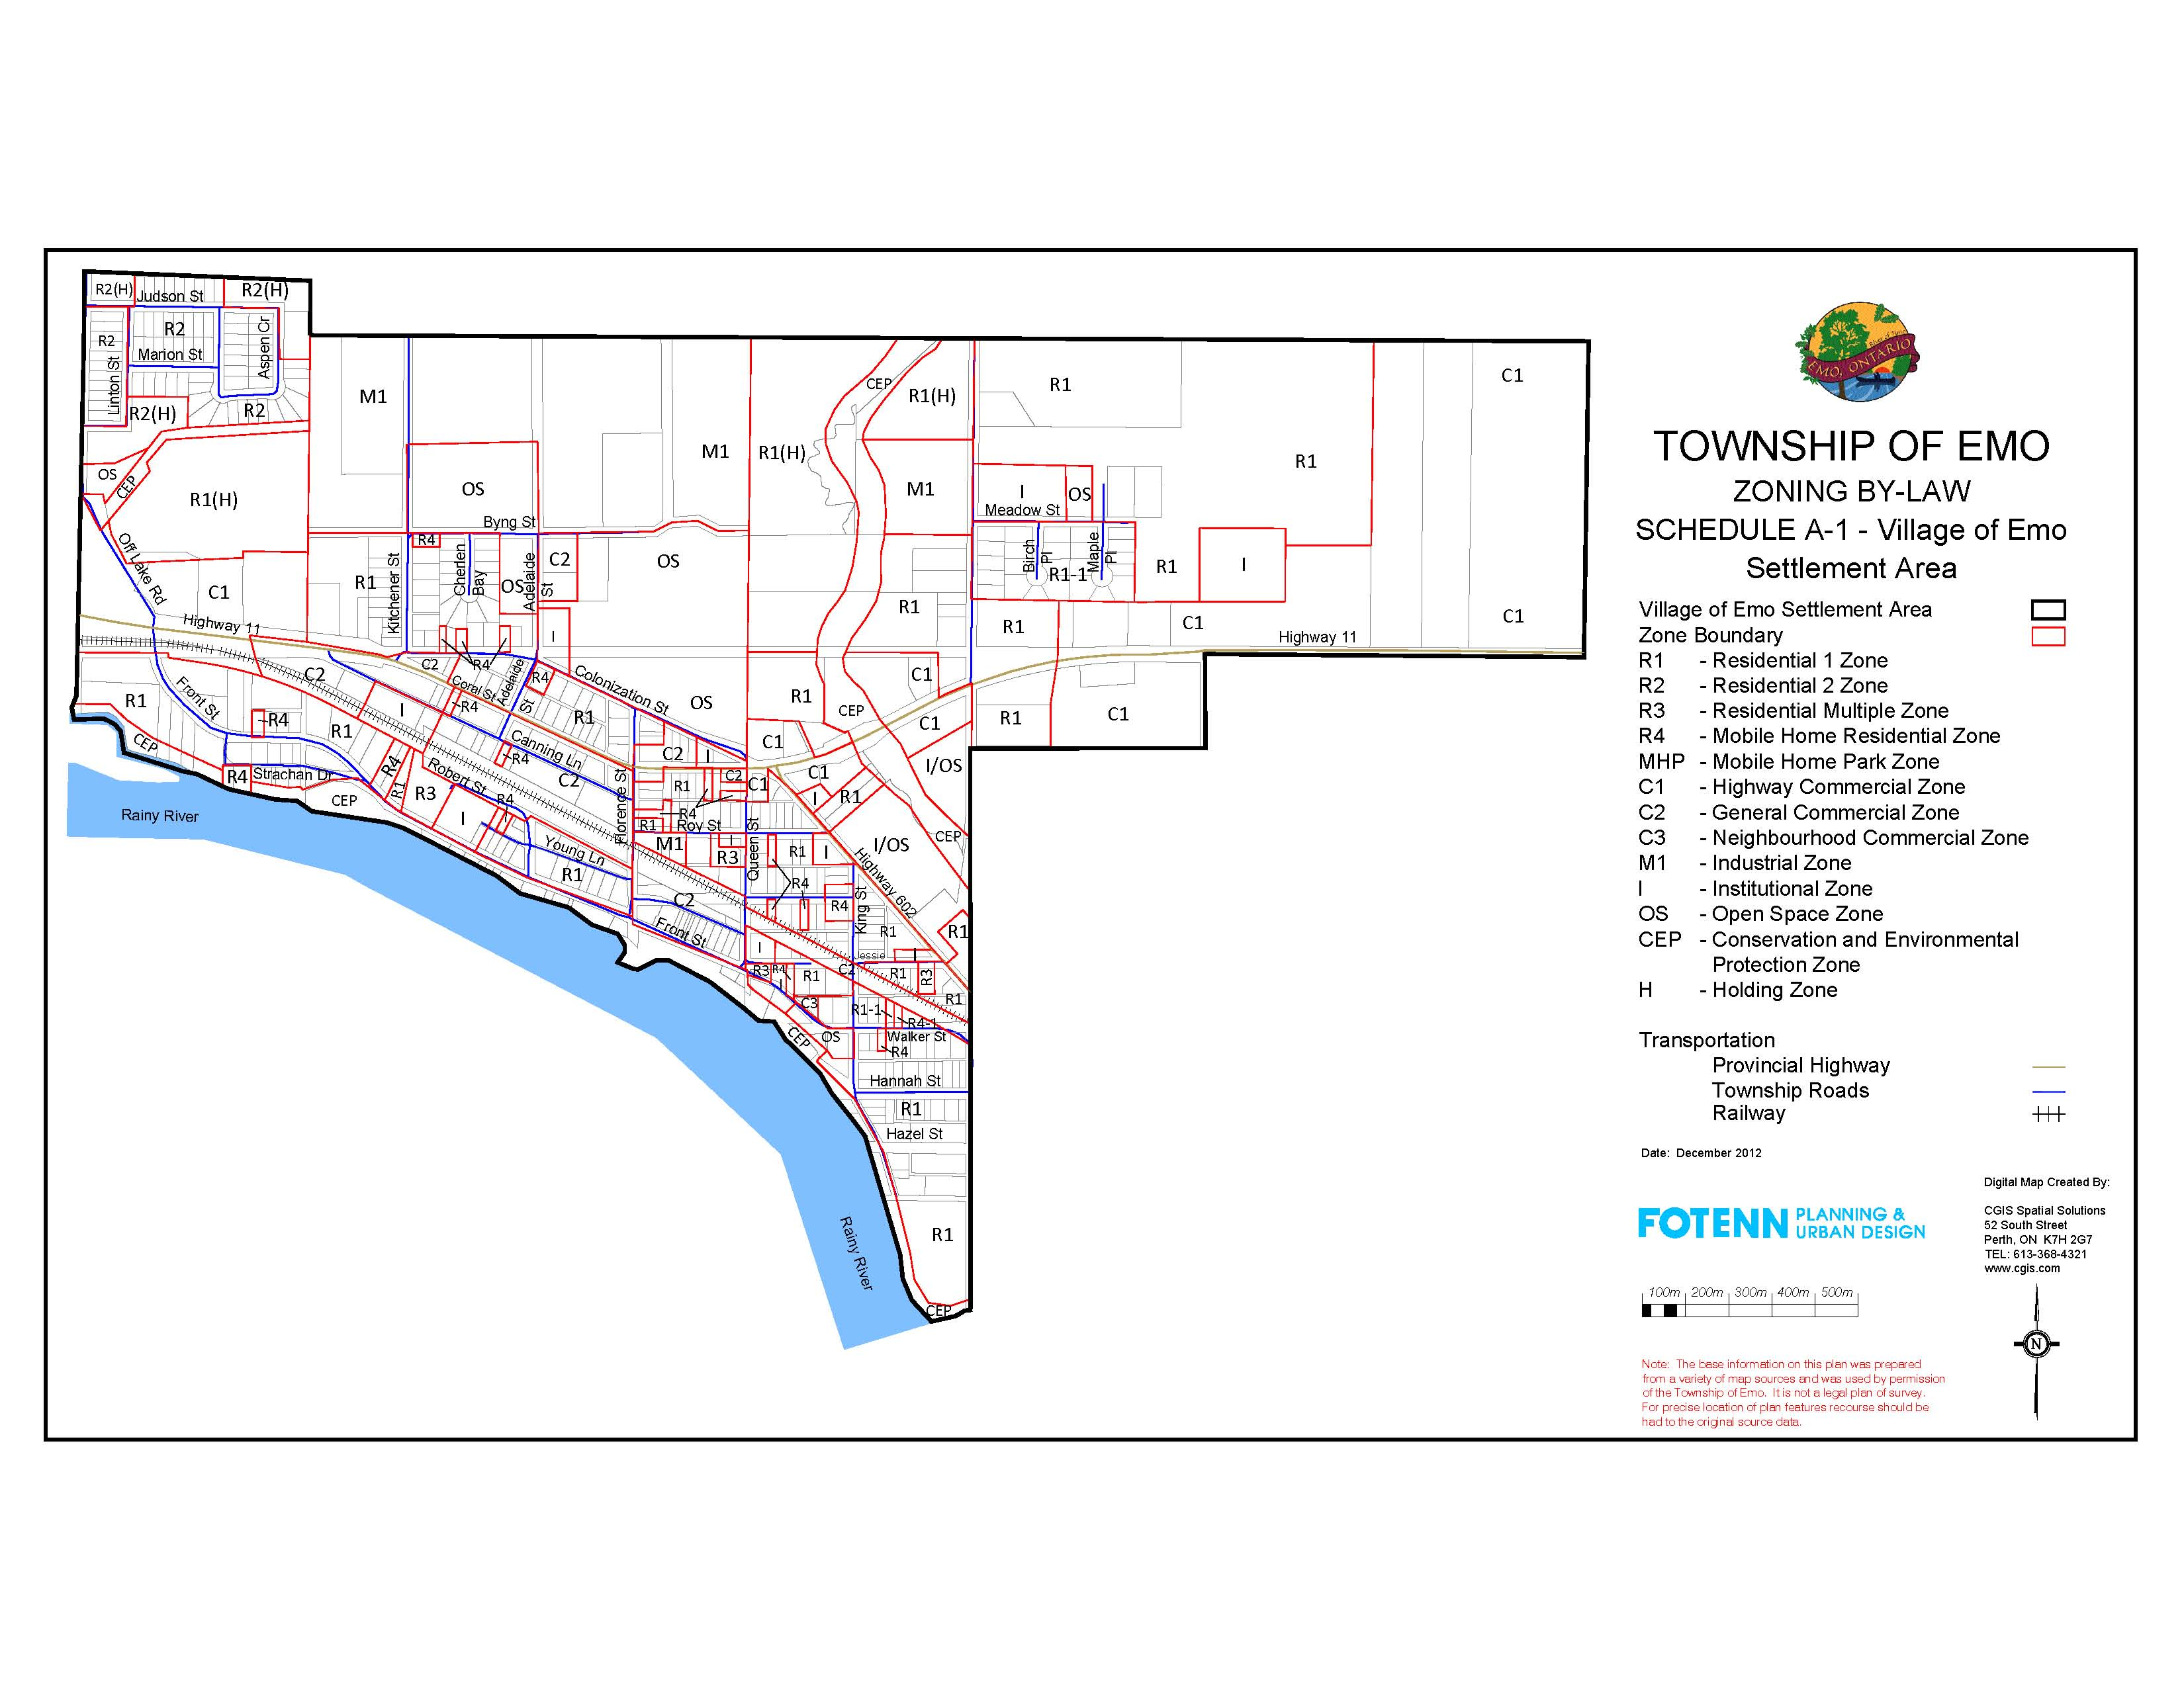
Change from R4 to R1.
Figure 1

  - That Schedule A-1 – Village of Emo Settlement Area be amended as shown on Figure 2.
Change from R4 to R1.
Figure 2
  - That Schedule A-1 – Village of Emo Settlement Area be amended as shown on Figure 3.
Change from C2 to R4.

Figure 3
  - That Schedule A-1 – Village of Emo Settlement Area be amended as shown on Figure 4.
Change from R4 to R1.
Figure 4
  - That Schedule A-1 – Village of Emo Settlement Area be amended as shown on Figure 5.
Change from R1 to R4.
Figure 5

  - That Schedule A-1 – Village of Emo Settlement Area be amended as shown on Figure 6.
Change from C2 to R1.
Figure 6

  - That Schedule A-1 – Village of Emo Settlement Area be amended as shown on Figure 7.
Change from C2 to R4.
Figure 7

  - That Schedule A-1 – Village of Emo Settlement Area be amended as shown on Figure 8.
Change from C4 to R1.
Figure 8

  - That Schedule A-1 – Village of Emo Settlement Area be amended as shown on Figure 9.
Change from R4 to R1.
Figure 9

  - That Schedule A-1 – Village of Emo Settlement Area be amended as shown on Figure 10.
Label as Charles Street
Figure 10

  - That Schedule A-1 – Village of Emo Settlement Area be amended as shown on Figure 11.
Change from R4 to R1.
Figure 11

  - That Schedule A-1 – Village of Emo Settlement Area be amended as shown on Figure 12.
Change from R1 to R4.
Figure 12

  - That Schedule A-1 – Village of Emo Settlement Area be amended as shown on Figure 13.
Change from R1 to R4.
Figure 13

  - That Schedule A-1 – Village of Emo Settlement Area be amended as shown on Figure 14.
Change from R1 to R4.
Figure 14

- That the Zoning By-law 2013-06 of the Township of Emo hereby supersedes the Township of Emo Zoning By-law 98-13;
- That Township of Emo By-law Number 98-13, as amended, is hereby repealed.
- That this By-law shall take effect and come into force upon third and final reading thereof.

Read a First and a Second TIME ON this 5th day of February, 2013.
READ A THIRD TIME AND FINALLY PASSED ON THIS 15TH DAY OF OCTOBER, 2013.

The Corporation of the Township of Emo

Vincent Sheppard, Mayor

Brenda Cooke, CAO/Clerk-Treasurer

