2013

Rural Municipality of Longlaketon #219

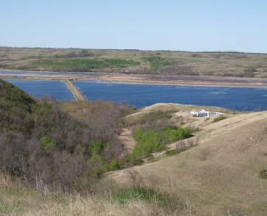
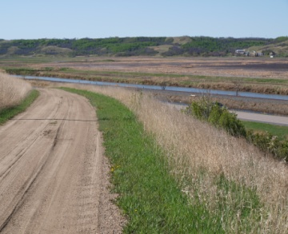
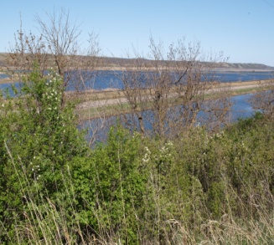

Official Community Plan
Bylaw 5-2013

M

Table of Contents
1 Introduction 4
1.1 Area Covered by the Plan 4
1.2 Enabling Legislation 4
1.3 Purpose of the Official Community Development Plan 4
1.4 Regional Context and Existing Framework 5
1.5 Regional Map 5
Community Issues & Priorities 6
6
1.6 Format of the Plan 7
2 Guiding Growth in the RM of longlaketon 8
2.1 Introduction 8
2.2 Guiding Principles 8
2.3 Goals of the Rural Municipality of Longlaketon 9
3 RM of Longlaketon Development Policies 10
3.1 General Policies for New Development 10
3.2 Agriculture and Resource 12
3.3 Country Residential Development 16
3.4 LAKESHORE DEVELOPMENT 20
20
Residential Policies 20
3.5 Utilities and Facilities 21
3.6 Ground and Source Water Resources 22
3.7 Transportation Networks 23
3.8 Economic Development 27
3.9 Emergency Response Planning 30
3.10 Outdoor Recreational Amenities and Heritage Resources 31
3.11 Community Services 34
3.12 Natural Hazard Lands: Flood and Slope Instability 35
4 Implementation and Action Plans 38
4.1 Making Things Happen 38
4.2 The Plan Guides Action 38
4.3 The Future is a Shared Responsibility 38
5 Inter-Jurisdictional Cooperation 40
5.1 Introduction 40
5.2 Inter-Municipal Cooperation 40
5.3 Revenue Sharing 41
5.4 Annexation 41
5.5 Treaty Land Entitlements and Specific Claims AND DUTY TO CONSULT 42
6 Administration 43
6.1 Planning Tools 43
6.2 Definitions 43
6.3 Adoption of the Official Community Plan 43
6.4 Adoption of Municipal Zoning Bylaws 43
6.5 Contract Zoning, Direct Control Districts and Planned Unit Development 44
6.6 Concept Plans 46
6.7 Comprehensive Development Proposals 46
6.8 Existing and Non-Conforming Uses 47
6.9 Development Levies and Agreements 47
6.10 Servicing Agreements 47
6.11 Subdivision Process 48
6.12 Monitoring Performance 48
7 Repeal and Effective Date of Bylaw 49
Appendix “A” Future Land Use Plans 50
Appendix “B” Reference Maps 50
Map 1: Recreational Amenities 50
Map 2: Utilities 50
Map 3: Transportation 50
Map 4: AGRICULTURAL POTENTIAL 50
Map 5: ENVIRONMENTALLY Sensitive Areas 50
Map 6: AIRPHOTO MOSIAC 50
Map 7: Shaded Relief WITH Drainage 50
Appendix “C” Development Review Criteria 51
Chart A: Development Review Criteria 51
Chart B: Sample Development Proposal “Berlin Developments” 53
INTRODUCTION 54
PROPOSAL SUMMARY 54
MARKET ASSESSMENT 55
PROPOSED IMPROVEMENTS 55
PROJECT PHASING 56
IMPACT ASSESSMENT 57
MARKETING STRATEGY 58
LAND USE POLICY AND ZONING IMPLICATIONS 58
SERVICING COSTS 59

Introduction

Area Covered by the Plan
This Official Community Plan, hereinafter referred to as the Plan, applies to the Rural Municipality of Longlaketon No. 219. The Plan enables growth and change through policies that will guide the municipality with its development-related decisions to ensure the area develops as intended by the Plan under an established decision-making process. This Plan will encourage a stronger, creative and more cohesive Municipality that can, through improved regional links, manage change towards a desired future by increasing regional capacity.

Enabling Legislation

The Planning and Development Act, 2007, provides the legislative framework for the preparation and adoption of an Official Community Plan. Official Community Plans address future land use, development and other matters of Official Community concern affecting lands within the plan boundaries as agreed to by the participating Municipality. In addition, each Official Community Plan must include procedures for the resolution of land use conflicts and provisions for administration, amendment and repeal of the Plan.
Legislative Framework:

The Planning and Development Act, 2007

This document is the Plan for the Rural Municipality of Longlaketon No. 219 to manage land use and development. This Plan is intended to guide the municipality for a period of fifteen to twenty years. The Municipality shall, in conjunction with the adoption of this Plan, amend, in accordance with The Planning and Development Act, 2007, its respective Zoning Bylaws as required to be consistent with the policies and provisions of this Official Community Plan.

Purpose of the Official Community Development Plan
The purpose of an Official Community Plan is to provide a comprehensive policy framework to guide the physical, environmental, economic, social and cultural development of the municipality or any part of the municipality.

In Saskatchewan, The Planning and Development Act, 2007 states that:
The Official Community Plan responds to the requirements of the Act by providing policies based upon “Community goals” for the conservation and use of municipal resources. The day-to-day decisions of the Municipal Council will be based upon these goals, objectives and the policies in this Plan to promote orderly and sustainable development throughout the Municipality. This Official Community Plan builds on the previous land use plans and will reduce uncertainty for both the public and private sectors with respect to the future use of land by promoting well-managed development.

Regional Context and Existing Framework
This Plan has been developed to guide pressures and opportunities by highlighting the land use potentials that exist in this Municipality. In addition, the Plan specifically addresses the area where we would like to see things happen!
The Municipality represents a planning area of approximately 1,025 square kilometres (396 square miles). The 2011 census records a total population of 962 residents in the Municipality, and a population density of 1 per square kilometres (2.3per square mile). There are over 390 dwellings in the Municipality. The Municipality is characterized by a low density rural population distribution, along with some country residential and cottage development.

The Town of Earl Grey and the Villages of Craven and Silton are located within the Rural Municipality.
The Rural Municipality has a variety of soils and aggregate including potential for potash resources. A large portion of agricultural lands in the Municipality have been under cultivation for years, and little natural vegetation remains except in the northern areas and valley areas. Livestock operations are dispersed within the Municipality with a balance of intensive hog production and cattle activity.

Heritage Resources in the Municipality include many traditional settlement sites which are identified and preserved. The Hudson’s Bay Last Mountain Trading Post and one of the oldest United Churches call this municipality home.

Regional Map

Community Issues & Priorities

Format of the Plan

The Official Community Plan is divided into six major parts:

An Introduction to the Official Community Plan, providing some general background information and guidance.
1

The vision, goals, general principles and general development policies which will guide the overall use, planning and development of land in the Municipality.
2

Policy directions are provided for all areas of the Municipality. Sections include: Agricultural Resource, Ground Water Resources, Recreational Resources, Historical Resources, Ground Transportation, Utilities, Industrial, Commercial, and Rural Residential Development.
3
An action plan for implementing the Official Community Plan.

4
5
An inter-jurisdictional dialogue is offered.

The tools and legislative supports available for Council to administer the Official Community Plan are highlighted.
6

Reference Maps: The series of reference maps attached in Appendix “B” provide supplementary information. These maps may be updated periodically by a resolution of the Rural Municipal Council. All Reference Maps are approximate and are subject to change. Reference maps are conceptual only and should not be used to make site specific decision.

Guiding Growth in the RM of longlaketon

Introduction
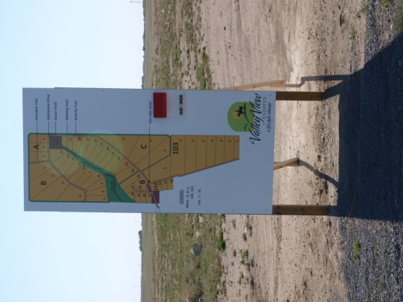
This Plan encourages some degree of change in the rural areas to manage the impacts and promote development opportunities. Guiding future population growth to support social-economic development in the Rural Municipality and adjacent Town and Villages is needed to assure a better future for the area. A dynamic Municipality requires a strategy to successfully promote agricultural diversification, business enterprises, job creation, and a variety of residential options to attract new residents. The potential benefits that will accrue to the greater community include employment, tax revenue, support for local business, as well as other economic and social opportunities.

Guiding Principles

This Official Community Plan:

- Encourages sustainable development and growth which efficiently uses land and existing transportation infrastructure, and provides for the affordable servicing of land in order to limit the fragmentation of land;
- Promotes new development in rural areas that is compatible with agricultural land uses, and complements the urban communities in the area;
- Recommends taking advantage of the proximity to the Long Lake and less than an hour from Regina to promote recreational, resource activity commercial, industrial and agricultural diversification to encourage business investment and expansion, job creation, business stabilization and economic growth;
- Supports inter-community co-operation through this Plan, and other public/private partnerships to stimulate community initiatives through land development in a sustainable manner that contributes positively to the well-being of all the communities in the area;
- Profiles the area’s economic, cultural, heritage and natural resources and the need to organize inter-municipal development initiatives; and
- Preserves, connects, and enhances natural areas like the Last Mountain Lake for eco-tourism, agriculture, health and recreation for their contribution to the quality of life enjoyed by residents.

Goals of the Rural Municipality of Longlaketon

Agricultural Pride: Agriculture continues to be the primary economic activity and land use in the Rural Municipality.

Residential Alternatives: A choice of alternate, affordable and complementary residential lifestyles is available throughout the region.

Vision Statement

The Rural Municipality of Longlaketon is a sustainable community that offers a country living lifestyle choice to residents and prime opportunities for agriculture and recreation

Economic Development: Enhanced municipal assessment base through quality development and a diversified local economy.

Environmental Management: Recognize the significance of sound development which serves to enhance and protect the environment and build on the unique surroundings of the region.

Sustainable Servicing: Appropriate municipal services and public utilities for the rural context provided in a financially responsible manner.

Community Development: Rural residents are encouraged to actively support the communities in the region as the focal point for community services to enhance our regional community.

Inter-Municipal Cooperation: To encourage dialogue among all municipalities when planning long-term growth strategies for the region that offers opportunities for all rural and urban Municipalities.

RM of Longlaketon Development Policies

General Policies for New Development
This section of the Official Community Plan outlines objectives and policies for the Rural Municipality of Longlaketon. Land uses such as agriculture, residential, recreation, commercial and resource based uses are appropriate in rural areas.

Rural areas shall continue to be differentiated from urban areas by less dense development and generous larger land parcels, where agricultural activities are the dominant land use within the Municipality. This land use will be supported and strengthened in order to maintain the rural character of the Municipality and the livelihood of residents.

The Rural Municipality of Longlaketon will strive, through this Official Community Plan, to provide policies related to land use, transportation, servicing and other aspects of planning that are consistent throughout the Municipality.

The Municipality shall have a sustainable form, mix of uses and densities that allow for the efficient use of land, infrastructure and public facilities. The Plan will help to identify suitable lands to attract a broad range of residential, business enterprise, recreation, institutional, and development to meet anticipated long-term needs for the area.

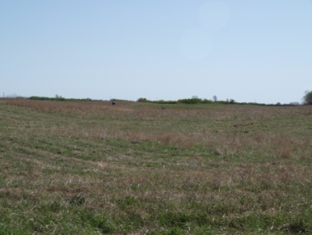
When reviewing applications for development, consideration shall be given to the proposal’s conformity with this Plan. A proposal shall be denied when it is detrimental to the health, safety, general welfare of persons residing or working in the area, or incompatible with existing or proposed land uses in the vicinity.

The Municipality will avoid unplanned development to achieve an orderly, efficient land use pattern which is possible to develop and service in appropriate phases. The Rural Municipality will work directly with the adjacent urban and rural municipalities to ensure complementary and compatible policies are adopted by all municipalities.

Future development shall integrate into the natural surroundings and shall complement the surrounding community design, landscape and vegetation. Planned development will help to increase land values, not be wasteful of the land resource, optimize public expenditure in services provision, recognize significant features and reduce access connections to Provincial roads and highways to minimize disruption to traffic flows.

The Rural Municipality shall promote economic development and competitiveness by providing for an appropriate mix and range of employment opportunities including agricultural, tourism, recreational, resource development, commercial, industrial, and institutional uses to meet long-term needs by ensuring the necessary infrastructure is provided to support current and projected needs.

Efficient settlement patterns that support community development shall develop in cluster or corridor form or adjacent to existing built-up areas and shall have a compact form, mix of uses and densities that allow for the efficient use of land, infrastructure and public facilities.

In managing growth and change, the Municipality shall maintain a long-term asset management plan to ensure growth will not place an undue strain on municipal infrastructure or public service facilities. Development and new subdivisions shall be encouraged to locate where servicing and infrastructure are in place or planned to support the intensity and type of development.

Major deviations to the Plan design and policies shall require an amendment. The Future Land Use Plan provided in Appendix “A” shows the general designation of land use. Cumulative effects, land fragmentation, best management practices, innovative procedures, development phasing, route modification, alternative construction techniques and impacts on municipal servicing shall be considered when reviewing all developments and their compliance with the Plan.

Land development shall be guided by Concept Plans and/or Comprehensive development reviews, depending on the scale, proposed use and geographic location. These plans or reviews, may serve to promote orderly, efficient and environmentally safe land use. Planned development can minimize public expenditure in service provision, identify environmental constraints and coordinate access points on Provincial roads and highways. Refer to Chart “A” in Appendix C for the development review criteria and a sample development proposal format in Chart “B.”

Servicing agreements shall be required at the time of subdivision approval to ensure that new subdivisions are developed to the standards of the Rural Municipality and to address other concerns specific to the proposed subdivision. Subdivision Fees or Development levies that recover the costs of extending/upgrading services to the new developments shall be required in accordance with The Planning and Development Act, 2007.

Land development shall also be evaluated on the degree of prematurity including the consideration of the number of unsold and undeveloped sites in previous phases of the area being subdivided/rezoned or similar sites in adjoining developments.

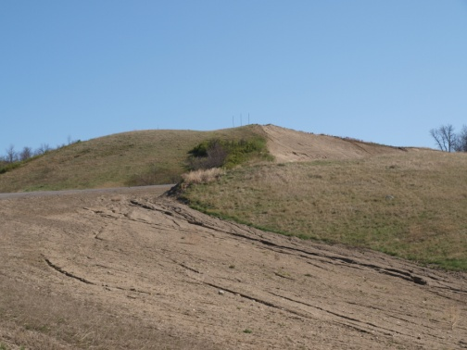
Development and new subdivisions shall be encouraged to locate where servicing and infrastructure are in place, or planned, to support the intensity and type of development. Development shall minimize the potential impact to drainage, landscape or other natural conditions and shall be required to mitigate on and off-site impacts.

All developments shall be required to have access to an all-season municipal road or highway. The addition of municipal roadway mileage will be limited to make the most efficient use of existing roadway facilities. Development will be encouraged to locate adjacent to roads which have been designed and constructed to accommodate their activities.

Development and subdivision plans that offer design features such as alternative energy sources, innovation in health, or environmental responsibility shall be encouraged where they are consistent with Plan policies. Facilities and activities that encourage or enhance energy efficiency, waste reduction, re-use, or recycling of wastes shall be accommodated.

The Plan will assist in providing a transition between urban municipalities and non-farm communities, and potentially incompatible agricultural and natural resource activities.

Policies must reflect the benefits of land use diversity and communicate the purpose when accommodating new development opportunities that can successfully co-exist with existing and evolving agricultural uses. Scattered non-farm development may lead to:
- Rural residential development speculation, which often leads to rising land costs and higher tax assessments.
- Land use incompatibility issues arising between agricultural uses and rural residential, commercial and industrial development.

Prior to approval of any large-scale development, the developer will be required to provide justification of demand to warrant subdivision and/or the potential benefits to the community, including employment, tax revenues and other economic and social opportunities. Refer to Chart “A” in Appendix C for the development review criteria and Chart “B” for a sample Development Proposal.

Agriculture and Resource
The Rural Municipality remains a vibrant agricultural base and contains a variety of farm operations and is home to an abundant aggregate base as well as a mineral base including potential potash resource development.
Objectives:
- To protect and promote the continuation and diversification of the agricultural industry;
- To identify and protect prime agricultural land, and to recognize areas in which the interests of the farmers will be paramount in land use and planning decisions, subject to the protection of the environment;
- To ensure flexibility for farm operators to engage in differing types and sizes of agricultural operations and to provide agricultural producers with the opportunity to take advantage of evolving technology;
- To encourage aggregate development for the benefit of the Municipality and to protect these lands from incompatible developments;
- To minimize community and environmental disruption from mineral extraction and aggregate related activities; and
- To provide for areas where non-farm development is compatible and welcomed.

Agricultural Policies

Protecting the dominant role of agriculture and promoting a full range of agricultural activities shall be accomplished in ways compatible with the environment and adjacent land uses where it is desirable and feasible to provide protection to such activities.

Agricultural land includes, but is not limited to, extensive agriculture, intensive agricultural operations, or secondary activities that will enhance the economic viability and diversification of the agricultural sector.

The development and operation of farms and farmsteads for field crops, pastures and livestock operations shall be encouraged to continue in the Rural Municipality. Innovative agricultural production methods which maximize sustainability shall be supported to enable producers the ability to diversify, process and potentially provide for the direct sale of locally produced commodities.

Intensification of agricultural activities shall be planned and sited recognizing their full potential and in a manner that requires minimal improvement to municipal servicing.

Highly productive prime agricultural lands should not be developed for non-agricultural uses, unless there is no suitable alternate site with equal attributes capable of serving the proposed use or if the development at the selected location meets an important public need.

Crop spraying, intensive agriculture production, pasturing livestock, and manure spreading are legitimate operations and should be restricted only by public health regulations and environmental protection measures, unless otherwise stated herein.

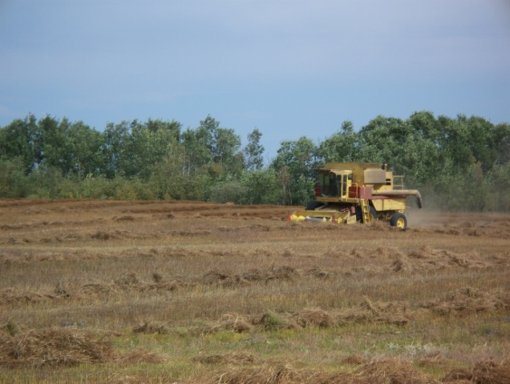
Legitimate farming activity shall not be curtailed solely on the basis of objections from property owners even though that activity was not practiced when the small holdings were created or non-farm uses were allowed. Agricultural operations using new technology or management practices that are environmentally sustainable shall be supported.

Existing agricultural enterprises which operate within normally accepted practices of farm management and in conformance with The Agricultural Operations Act, 1995 shall be protected from new development which might unduly interfere with their continued operation.

Small land holdings for small-scale or specialized agricultural operations may be considered for approval, provided that such proposals are compatible with other existing agricultural operations, and that the size of the proposed parcel is appropriate for the intended use.

Agri-Industrial developments which directly serve farming activities, and either process or store agricultural produce or products shall be allowed in agricultural areas. When possible, preference shall be given to locations on lower quality land.

Rural and Agri-Tourism ventures shall be encouraged throughout the district.

The use of best management practices for agricultural enterprises, particularly with regard to manure management and chemical applications, shall be encouraged in order to minimize risks to groundwater and surface water.

New developments in rural areas shall be located to be compatible with existing agricultural operations. The establishment of urban-like uses in rural areas, which would compete with urban areas, or have the potential to create land use conflicts, shall be discouraged.
- Development along existing all- weather road allowances where road construction and improvement are not required shall be encouraged.
- Separation areas, landscape buffers or shelterbelts, shall be encouraged to separate agricultural land use from urban municipalities, residential acreages, multi-parcel subdivisions or recreation areas.

Intensive Livestock Operation Policies

Proponents and operators of intensive livestock operations will be required to develop facilities and conduct their operations in a manner which reduces the production of offensive odours and the potential for pollution of soils, groundwater and surface water.

Livestock operations will be characterized by the total number of animal units and animal type. Intensive livestock operations will be required to locate where they provide an appropriate land base size to support their operation and where they have a sufficient land base for manure application.

The development, application and environmental monitoring of livestock operations shall be undertaken in consultation with Saskatchewan Ministry of Agriculture to ensure the land use decisions and agricultural operating practices regulated by the Province are coordinated with the Rural Municipality.

Building setback standards shall be applied to new intensive livestock development along municipal roads, in order to provide a measure of safety for the travelling public, to provide a measure of buffering of buildings from roadway nuisances, such as noise and dust, and to reduce snow drifting problems along rural roads.

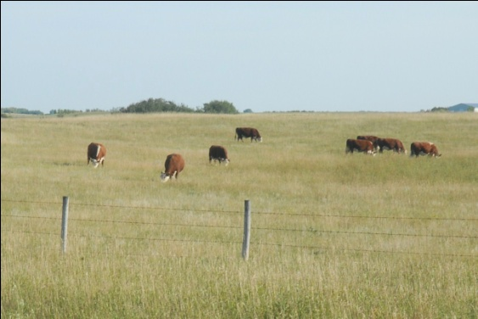
The Zoning Bylaw shall provide for mutual separation distances to be established between livestock production operations and residences not related to the operation and to provide separation buffers between new and expanding livestock operations and residential areas to minimize environmental and socio-economic impacts upon residential uses.

The separation distance may vary, depending upon density of residential use, size of community, nature and intensity of livestock operation and method of manure storage and management. Special review and approval shall be required for residences and other non-agricultural developments, which may be proposed, within this mutual separation distance.

The Rural Municipality shall work co-operatively with Water Security Agency (SWA) to monitor ground water resources and may require an annual assessment of residual nutrient levels in the soil, ground and local surface water by a qualified professional recognized by SWA demonstrating:
- The development and on-going operation of activities associated with the land use will not pose a risk or cause pollution of the soil, surface water or groundwater resources; and
- The precautionary measures which are required to be taken to sufficiently mitigate the potential risks of endangering soil, surface and groundwater quality resources.

Aggregate and Mineral Resource Policies

Resource development that benefits the district will be encouraged throughout the Municipality according to their respective locational requirements, separated from incompatible activities, with minimal community and environmental disruption.

Land designated natural resources in the Plan reference maps, includes the development of mineral resource extraction e.g. potash and a Potash Disposition Map is one of the Reference Maps. Proposals for these activities shall be referred to the appropriate government agencies for their review.

The Natural Resource Reference map shall indicate the location of sand and gravel resources with a “medium to high” sand and gravel extraction potential to assist with the management and protection of these resources from other developments which may conflict with their operation.

Existing extraction operations and lands containing a valid mineral disposition shall be protected from incompatible and potentially incompatible land uses, in nearby areas. In areas with known aggregate resources, or areas having high discovery potential for these resources, uses shall be limited to non-intensive agriculture (i.e. livestock grazing, cropping) temporary uses or other uses that will permit continued access to the resource.

Extraction operations including such minerals as potash and petroleum resource operations shall be protected from incompatible and potentially incompatible development and activities that would restrict exploration hinder their expansion or continued use, or which would be incompatible for reasons of public health, public safety or environmental impact.

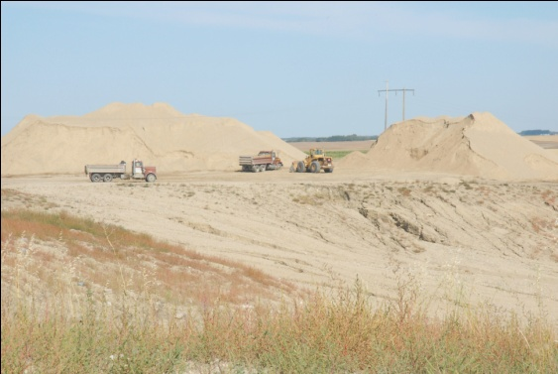
The exploration, development, production and termination of all aggregate and mineral resources shall be undertaken in a manner that is environmentally safe, stable and compatible with adjoining land. Disturbance shall be minimized by using the best available techniques and practices to reduce the overall footprint of activity during all phases of construction, operation, reclamation and abandonment. Consideration shall be given to the ability of natural landscapes to sustainably support reclamation efforts.

Buffer strips should be established around existing and potential aggregate resource sites in order to protect the aggregate and quarry deposits from incompatible adjacent land uses. The buffer strip should be determined in consultation with the Saskatchewan Ministry of Energy and Resources.

Country Residential Development
The Rural Municipality recognizes the need to provide opportunities for a balanced variety of residential options for the residents. These options range from single parcel residential to higher density options while maintaining the rural character.

General Policies

Residential development shall be encouraged to maintain the country-living environment which retains its land value, where land use conflicts are avoided and where efficient cost effective municipal services can be provided.

The subdivision of land for Country Residential purposes shall meet all requisite government department/ministry/agency requirements including but not limited to Saskatchewan Ministry of Environment, Ministry of Government Relations, the Regina Qu’Appelle Health Region and Water Security Agency.

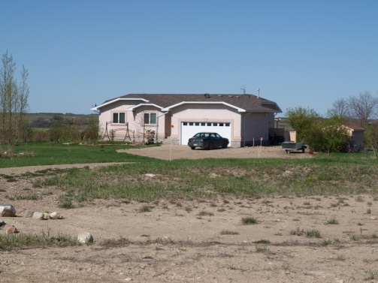
All residential subdivisions, regardless of the level of development, shall have access to an existing all-weather road and the proponent may be responsible to enter into an agreement with the Municipality to upgrade an existing road or develop a new road access to the municipal standard. The proponent shall be solely responsible for all of the costs of the new or upgraded roadway construction which will be addressed through a Development or Service Agreement.

Residential subdivisions shall be required to provide adequate physical separation through the implementation of design buffering techniques, transitioning land uses, shelterbelts or landscape buffering from adjacent agricultural operations.

Residential subdivisions shall seek to minimize the loss of habitat and wildlife corridors by retaining and incorporating natural vegetation and watercourses within their location and design.

Where subdivision is proposed adjacent to a watercourse Council will identify and designate the channel, adjacent floodplain, and significant natural habitat as Environmental Reserve to protect sensitive areas and preserve the potential for public access. This will be done through consultation with relevant agencies and adjacent municipalities.

Residential subdivision shall not be permitted:
- Within 1 km (0.6 mile) of a hazardous industry except in instances where transition and buffering can mitigate concerns;
- Within 1 km (0.6 mile) of a rural industrial site except in instances where transition and buffering can mitigate concerns;
- Within 305 m (1000 ft.) of a sewage lagoon site;
- Within the required separation distances from intensive livestock operations as provided within the Zoning Bylaw, or
- Within 457 m (1500 ft.) of a solid waste disposal site.

Planned development will help to increase land values, not be wasteful of the land resource, minimize public expenditure in service provision, recognize significant community features in maintaining the community lifestyle and be designed to be compatible with the surrounding areas.

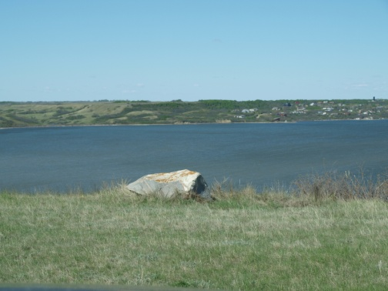
Community Service lands include institutional, public services, recreational, health, cultural or educational uses, shall recognize and assess the impact future adjacent land uses may have on their activity. Each rezoning proposal will be evaluated based on individual merit and its compatibility with surrounding land uses.

Non-residential developments such as commercial developments along the Highway #’s 6, 20 and 22 Corridors that are intended to provide services to the community and the surrounding population shall be permitted. Those uses or activities shall be located so as to be compatible with other existing or proposed uses subject to compliance with commercial policies contained herein.

Residential developments will be encouraged to locate in proximity to regional and complementary public uses (e.g. recreation facilities, parks, and libraries), institutional uses (e.g. schools) and commercial uses.

All Residential Development proposals should be guided by Concept Plans. Development Review Criteria and a sample Development Proposal are provided in Appendix C. Concept plans should address the following:
- Future major roads;
- Drainage systems and improvements required to meet non-agricultural drainage requirements;
- Major open space (including unique physical) areas;
- Cultural and archaeological significant areas;
- Areas requiring protection through buffering or other means;
- Major hazards such as flooding, areas of high water table, and slope lands;
- Staging of development and future development of or expansion into adjacent land; and
- Adjacent municipalities’ planning and future growth needs.

Single Parcel Country Residential Policies

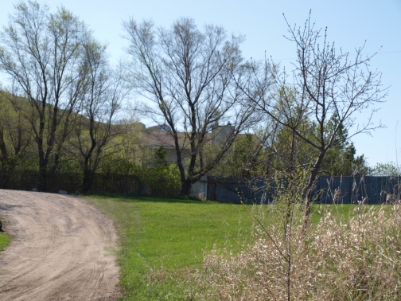
To protect the predominant role of agriculture and encourage the retention of larger parcels for continued productive agricultural purposes, the subdivision of agricultural holdings for residential purposes shall be limited to the creation of four (4) non-farm building sites per quarter section (64.8 ha) subject to rezoning to an appropriate District.

Where an agricultural holding has been subdivided to its full potential under these policies, no further residential development shall be permitted on the balance of the agricultural holding.

Residential subdivisions shall be planned and located in order that:
- Services such as school bussing, snow removal and protection services can be provided with reasonable efficiency and without undue cost to the Rural Municipality;
- Increased assessments associated with residential development are confined and upward pressure on taxation and limitation of uses of agricultural or resource land is minimized;
- Normal agricultural activities will minimally affect the quiet enjoyment of the non-farm residential area.

Single Parcel residential development shall be required to provide for such onsite services as is deemed necessary by the Municipality, at the expense of the developer, including but not limited to, upgrading municipal roads to an all-weather standard as a condition of approval.

Single Parcel residential development shall not be permitted in areas subject to flooding, erosion, or bank instability, unless detailed analysis of the specific site, prepared by a qualified engineer can prove the development to be safe from the aforementioned hazards.

Residential development along provincial highways shall meet all requisite highway regulations pertaining to access and location of structures.

On-site wastewater disposal systems must receive approval from Region Qu’Appelle Health Region prior to installation. The location and size of building lots shall reflect the capability of local soils to adequately support an approved on-site wastewater management system.

Multi-Parcel Country Residential Policies

A Comprehensive development proposal (refer to Appendix C for a sample development proposal and the development checklist requirements) shall be completed by any person proposing to rezone, subdivide, or re-subdivide land for multi-parcel country residential or hamlet development prior to consideration of an application by Council. The review shall be undertaken according to the standards provided in the Zoning Bylaw and shall address all matters of land use integration, potential conflict mitigation and the provision of services to the development. Once the Plan is registered, no further subdivision will be permitted, that increase the number of lots in that development.

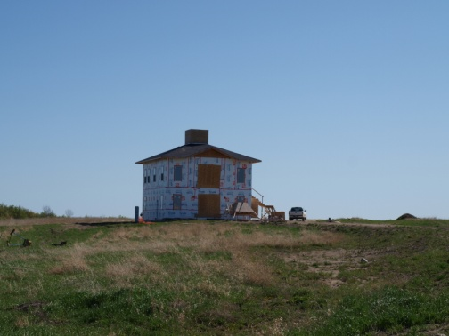
The Future Land Use Plan and Development Overlay District in “Appendix A” indicates areas designated for future cluster higher density residential activity.

Multi-parcel country residential subdivisions shall take into account the health, safety and general welfare of the residents, the viability, and character of the adjacent urban areas and will ensure that the regional development opportunities are addressed.

Where a multi-parcel country residential subdivision is proposed on lands abutting an existing urban area or multi-parcel country residential development, Council shall require the proposed development to be designed to complement the existing development including measures such as visual buffering, lot site separation, complementary lot sizing or any other measures necessary to achieve compatible land use and development. The development will need to address drainage and servicing impact on not only the immediate development but also on adjacent lands.

Council shall determine the number and arrangement of approved lots within a subdivision application on a case-by-case basis upon review of a comprehensive development review and having consideration for:
- The carrying capacity of the lands proposed for development and the surrounding area based on site conditions, environmental considerations and potential impacts, and other factors that may warrant consideration in the design of the proposal;
- The suitability and availability of municipal and other services and infrastructure necessary to support the proposal; and
- The compatibility of the proposed subdivision design with that of the surrounding area.

Development of country residential lands adjacent to urban boundaries such as Silton, Earl Grey and Craven will be examined on a case-by-case basis and with consultation between affected municipalities. Country Residential developments within 1600 meters (1 mile) of an urban municipality’s boundary will require the preparation of a Concept Plan and a Comprehensive development proposal to illustrate how the proposed development will integrate with the existing urban municipality. Preference will be given to well-planned clustered residential development.

Multi-parcel country residential subdivisions shall enter into servicing agreements as provided in Section 6.10 of this Plan, including any considerations the Municipality deems necessary in accordance with The Planning and Development Act, 2007.

Appropriate development standards for residential subdivision including site area, frontage, boundary and roadway setbacks, and all other relevant standards shall be applied through the Zoning Bylaw.

The developer shall ensure, to the satisfaction of the Municipality that alteration to drainage, landscape, or other natural conditions occurs in a way that avoids or mitigates on and off-site impacts.

If a centralized system is built, the developer shall create a wastewater management (septic) system utility and shall provide the Municipality with regular qualified reports at intervals determined by Council on a case by case basis confirming that all onsite wastewater systems are being adequately maintained, or identifying necessary remedial works to be undertaken by the property owner and confirming that the required remedial works have been completed.
.

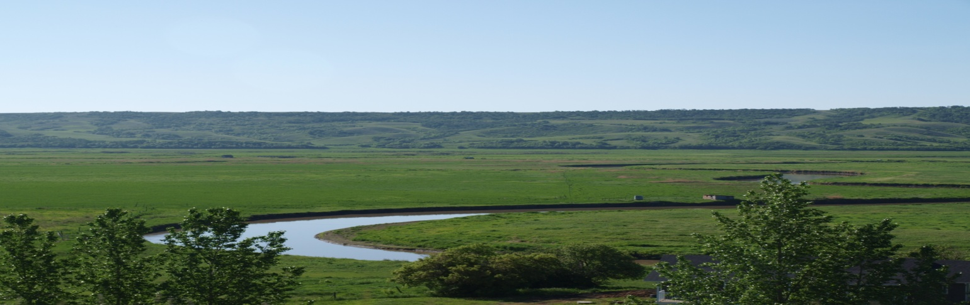

LAKESHORE DEVELOPMENT
Lakeshore development will be limited within the Rural Municipality, and high quality developments, will be the emphasis of further development.

- To maintain a high quality of development and style compatibility in residential areas through phased development in an efficient, sequential and staged manner.
- To encourage the infilling and selective redevelopment of presently vacant or under-utilized lots to maximize existing municipal services.
- To provide a comparable level of utility and public amenity services to all residential areas.

Residential Policies
.1 The Multi-Parcel Policies will apply where applicable for Lakeshore Development; in addition a variety of housing styles and choice of lot sizes shall be encouraged to provide greater housing alternatives. Larger residential lots retain the resort nature and ensure there is adequate separation distances to enable private water wells.
.2 New residential developments will be based upon appropriate planning and engineering studies to ensure proper land use design and engineering infrastructure. The development of Concept Plans for growth areas will be required.
3. Single Detached dwellings are the preferred form of housing type in the residential areas. Accessory buildings (i.e. garages, sheds etc.) shall only be permitted after the principle residence has been constructed.
.4 In areas where land is re-developed or infilled for residential use, the full range of residential options shall be explored in determining the best product for the specific redevelopment. Infill shall be encouraged in existing residential areas.
.5 New residential areas shall be developed and integrated with existing development in a manner that facilitates linkage to the community, efficient servicing, and adheres to appropriate development standards to ensure an equitable quality of life for all residents.
.6 Residential developments shall occur where municipal services are present or where they can be economically provided. Rezoning from another land use district to a Residential District will be considered where servicing can be economically and safely supplied to a standard equal to the remainder of the municipality.
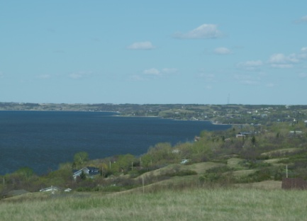
.7 Home-based businesses will be accommodated provided that they are clearly secondary to the principal residential use of the dwelling unit, compatible with the surrounding residential area.
.8 Non-residential developments will not be allowed in residential areas except for developments that accommodate municipal services and Community Service/institutional uses compatible with the residential area.

.9 If a centralized system is built, the developer shall create a wastewater management (septic) system utility and shall provide the Municipality with regular qualified reports at intervals determined by Council on a case by case basis confirming that all onsite wastewater systems are being adequately maintained, or identifying necessary remedial works to be undertaken by the property owner and confirming that the required remedial works have been completed.

Utilities and Facilities
The Rural Municipality of Longlaketon maintains a variety of public utilities and infrastructure including roadways and a transfer station.
Objectives
- To protect existing public and private utilities, from land uses which may adversely affect their operation.
- To ensure the appropriate levels of utilities are provided for the health and well-being of the residents, businesses and institutions in the Municipality.
- To extend municipal services in an efficient manner at the cost of the developer.
- To ensure long term viability of the Fairy Hill water Cooperative low pressure water line.

Policies

Cooperation will be encouraged with Sask Power, Sask Energy, Trans Gas and Sask Tel and other similar utilities to ensure the provision of their services in the most economical and efficient manner possible.

Essential activities of government and public and private utilities including alternate energy generating systems such as wind energy generating systems shall be permitted in any land use designation subject to requirements in the Zoning Bylaw. Such uses shall be located and developed in a manner, which is sensitive to and will minimize any incompatibility with neighbouring land uses.

Prior to the installation of major utility systems, such as electrical transmission lines, wind energy systems and communication lines or towers, the utility companies are encouraged to consult with the Municipality and the community at large on matters such as route selection and potential impact on local road networks.

New Pipelines should be preferentially routed through areas causing the least environmental impact either paralleling through existing disturbed lands, on rights-of-way or in areas of tame pasture or cultivation. Pipeline rights-of-way may be identified as passive open space that could be used for pathways, subject to all easement rights and other conditions that would maintain the safety and integrity of the pipeline facilities. The National Energy Board (NEB) process addresses pipeline development and it is the approval authority. The Municipality will ensure that any municipal development standards are consistent with Federal and Provincial requirements.

Separation distances from existing public works facilities shall conform to Provincial regulations. Any planned future expansion shall minimize the encroachment of incompatible lands near landfills, waste management facilities, airstrips, transportation corridors, rail yards, and industrial activities.

The use of existing municipal infrastructure shall be optimized wherever feasible before consideration is given to developing new infrastructure and public service facilities. Infrastructure and public service facilities shall be provided in a coordinated, efficient and cost-effective manner to accommodate projected needs by integrating servicing and land use considerations at all stages of the planning process.

The Rural Municipality shall continue to work with other municipalities in the region to:
- Pursue a comprehensive waste management plan for solid waste management;
- Adopt consistent wastewater disposal requirements; and/or
- Collectively approach and plan for future water utility provisioning where possible.

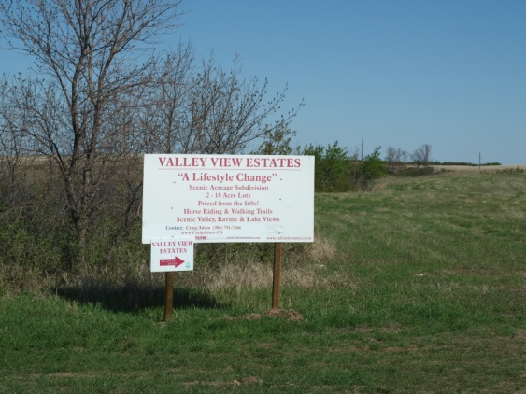
All development which requires water shall be adequately serviced with a potable and sufficient water supply on-site.

All development requiring sewage facilities shall be adequately serviced with an approved, on-site or central sewage system in accordance with Provincial and Municipal requirements.

The physical and economic ability to extend services to specific areas within the Municipality should be logical, reasonable and cost effective.

Lands adjacent to other municipalities, where infrastructure capacities exist, may be the subject of Inter-Municipal servicing agreements. Where it is appropriate, necessary and/or desirable, further to this Plan, the municipalities will endeavour to enter into agreements respecting municipal servicing for lands that are suited for future servicing with municipal water and sewer by virtue of their proximity, access, topography and soil characteristics. When an Urban municipality and the Rural Municipality of Longlaketon enter into such an agreement to service land, the agreement shall address any future boundary alteration impacts.

Ground and Source Water Resources
The Rural Municipality is located in an area with numerous waterbodies, creeks and watercourse which provide abundant water, however require a high level of safeguards to ensure long-term sustainability and water quality.
Objectives
- To ensure that all land use in the Municipality address sustainable water resource management
- To manage ground water resources in a manner that would not deprive existing users of their water supply and would not have a known detrimental effect on ground water potential.
- To ensure that the public health is protected by locating unserviced subdivisions only where soil and ground water conditions can sustain development and not pollute aquifers.

Policies

Developments shall not deplete or pollute groundwater resources within the Municipality and shall occur in a manner which sustains the yield and quality of water supply. Land development within ground water pollution hazard areas shall require a detailed analysis of the specific site, prepared by a qualified engineer.

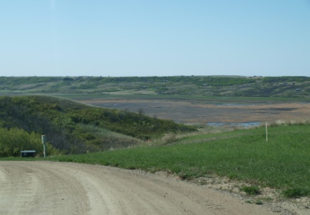
Developments will be encouraged to ensure that waterways, water bodies, shore land areas and groundwater resources are sustained. Development proposals, which may impact riparian systems or water bodies, will be referred to Water Security Agency for review and advice prior to approval.

Waterways and/or waterbodies in the Municipality may require protection to limit impacts of development. The Rural Municipality will seek opportunities to work with other municipalities and government agencies to investigate and improve the quality of water in Last Mountain Lake and Qu’Appelle water system and other small bodies of water draining into the region. This may be achieved through site-specific planning programs and cooperation with Federal, Provincial or regional programs.

The extent of protection required will be directly related to the characteristics of the local situation. The size and configuration of the waterway and water body, the need for public access, environmental characteristics, and economic potential will all have a bearing on the method of protection adopted. These studies shall be undertaken by a qualified professional at the expense of the developer.

Buffer strips should be maintained adjacent to watercourses and water bodies to allow for shoreline protection measures against erosion and flood hazards. Wetlands shall be preserved, whenever possible, for the benefit they serve as catchment basins for drainage.

The use of best management practices for agricultural enterprises, particularly with regard to manure management and chemical applications, shall be encouraged in order to minimize risks to groundwater and surface water.

Transportation Networks
The Rural Municipality is well served by a network of well-maintained Municipal roads in a rural setting. In addition the proximity to the Highway No’s 6, 20, 22 and 99 provide development opportunities to the Municipality and region.

Objectives
- To establish safe, efficient and convenient transportation facilities and service for all users.
- To provide a network of municipal roads to accommodate anticipated traffic movements within the Rural Municipality and provide an effective linkage to the Provincial highway system.

General Policies

Transportation networks and land use considerations shall be integrated at all stages of the planning process. A land use pattern, density and mix of uses should be promoted that minimize the length and number of roads to make efficient use of existing and planned infrastructure. Connectivity within and among transportation systems should be maintained and, where possible, improved including connections which cross jurisdictional boundaries.

The Municipality will continue to work with the East Central Area Transportation committee to plan, advocate and designate transportation network priorities and needs and will endeavour to enter into agreements to develop future municipal roads, strategically in the area in an economically and efficient manner.

Transportation facilities, which include such facilities as primary highways, secondary roads, airports and railways, should be protected from land uses which affect the safe and efficient operation of these facilities. To minimize the encroachment of incompatible lands near airports, transportation corridors and rail yards, adjacent lands shall be set back from these existing facilities and any planned future expansion.

Transportation facilities and rights-of-way should be planned and constructed in a manner that would minimize their negative impacts on existing and future proposed adjacent and surrounding land uses.

Where an area of development is bordered on one side by a major transportation corridor, such as a highway or rail line, new development should, where appropriate, be directed to the same side to avoid the need for local traffic to cross the corridor.

Road Policies

New developments shall have access to an existing all-weather road unless the proponent enters into an agreement with the Rural Municipality to upgrade an existing road or develop new road access to a standard agreed upon by the Municipality. The development of such a road must be on the priorized Municipal road system. The proponent shall be responsible for all of the costs of the new or up-graded roadway construction.

Developments adjacent to primary highways, secondary roads and railways should be located in such a manner as to achieve safe and efficient access.

Land uses which generate significant amounts of regional vehicular traffic and/or significant truck traffic shall be encouraged to locate in proximity to major municipal roadways, provincial roads and provincial highways.

Proposed developments which may be adversely affected by noise, dust and fumes from roadways and railways should be encouraged to locate where there is adequate separation from these corridors and/or to incorporate sound barriers or landscaped buffers to mitigate these impacts.

Where there are anticipated high volumes of truck traffic, the Municipality may designate certain roadways as truck routes, in order to limit deterioration of the local road system and to minimize safety problems and nuisance factors with adjacent communities.

Commercial or industrial developments that require large land area or are hazardous in nature may be located adjacent to Provincial roads or highways subject to all policies in this Section. Strip development, where each relies on direct access, shall have consolidated access at major points of intersection of Provincial highways and municipal roadways.

All developments will ensure safe access and egress from adjacent roadways without disrupting their transportation function by locating:
- On service roads adjacent to highways;
- On municipal grid roads adjacent to hamlets; or
- At existing intersections along range and township roads; and shall
- Be in conformity with all Municipal, Provincial and Federal transportation regulations, including but not limited to building and sign regulations as well as any control radii regulations.

Development along Provincial highways shall:
- Be encouraged to consolidate access at major points in order to provide a high standard of safety;
- Require access permits from the Saskatchewan Ministry of Highways and Infrastructure;
- Provide road systems where possible which integrate with existing road networks and which satisfy current and future needs; and
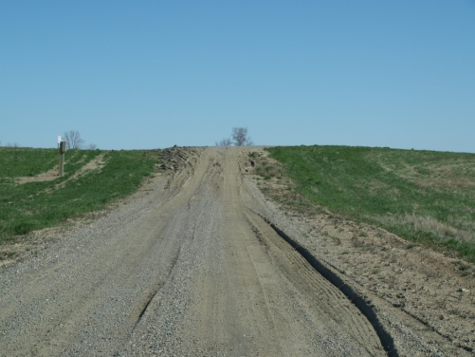
- Not be permitted where strip development is created with frontage less than 150 metres (492 feet) per lot and with individual direct access to the highway. Exceptions will be considered where adjacent development has already occurred.

All proposals which create new building sites and any development of a structure or access that is to occur within the control areas of Provincial highways under provincial authority will be subject to review approval by the Saskatchewan Ministry of Highways and Infrastructure prior to the issuance of an access or a development permit.

Building setback standards shall be applied to new development along municipal roads, in order to provide a measure of safety for the travelling public, to provide a measure of buffering of buildings from roadway nuisances, such as noise and dust, and to reduce snow drifting problems along rural roads.

Municipal road allowances shall be maintained for public access. Any proposals for clearing, cultivation or cropping of unimproved road allowances shall be subject to review and approval by the Municipal Council.
Railway Policies

The Municipality, through this Plan, shall provide for efficient and effective land use and transportation planning. This includes consultation with neighbouring property owners, including railways, in order to reduce the potential for future land use conflicts and provide adequate protection for rail infrastructure. The primary situations include:

New land development or redevelopment in proximity to existing rail operations;

new or significantly expanded rail facilities in proximity to existing residential uses; and

road/rail crossing issues.

The Municipality will support integrated transportation planning involving provincial, municipal, Port authorities and multiple railways in order to balance rail capacity upgrades, minimize community impacts and ensure that economic benefits occur.

The Municipality shall be pro-active in identifying, planning and protecting rail corridors and yards for their optimal use together with the Railways. The Municipality shall coordinate development approvals with the Railways that also require rail regulatory approvals to increase awareness regarding the railway legislation, regulatory and operating environment.

Safety at road/highway and railway crossings is a concern and planning is necessary to consider alternatives to creating new grade crossings, including upgrading and improving safety at existing crossings and grade-separated crossings.

Consultation with the Railways shall be required when a potential development is proposed for a:
- Development or redevelopment proposal in proximity to rail facilities or for proposals for rail-serviced industrial parks;
- Road and utility Infrastructure works which may affect a rail facility;
- Transportation plans that incorporate freight transportation issues; and
- All new, expanded or modified rail facilities.

Proposed developments which may be adversely affected by noise, dust and fumes from roadways and railways should be encouraged to locate where there is adequate separation from these corridors and/or to incorporate sound barriers or landscaped buffers to mitigate these impacts.

Property owners should be informed of any required mitigation measures to ensure proximity issues are addressed now and into the future. Notification of rail operation legal agreements and caveats registered on Land titles shall be provided to future property owners.

Development review of residential or other sensitive land uses proposed within an influence area should include noise and vibration and other emissions studies to assess the suitability of the proposed use and to recommend mitigation requirements for development in close proximity to rail facilities and for significant rail facility expansions that bring rail activities closer to sensitive land uses.

Sensitive land uses proposed adjacent to railway corridors shall be buffered and/or separated through setbacks, fencing, site grading, berms and landscaping to prevent adverse effects from noise, vibration, odour, fumes, and to promote safety. (i.e. site access and crossing reviews, setbacks, sightlines). Building setbacks and berms are intended to provide protective buffers and barriers to reduce the risks from a train derailment or other incidents and also to provide some noise and vibration attenuation.

The Rural Municipality, together with the Railways, shall strive to improve information-sharing regarding existing and future planning efforts through early consultations in advance of proposed land use or transportation changes, projects or works. The Municipality shall request notification from the Railways, to assist landowners and other stakeholders with implementing appropriate mitigation measure when new a proposal for new rail facilities, or significant expansions to existing facilities, are located in proximity to existing sensitive development. The Rural Municipality should consult with the railways regarding proposed land development and/or infrastructure projects which may have impacts on existing drainage patterns. Similarly, the railways should consult with the Municipality where facility expansions or changes may impact drainage patterns to adjacent uses.

Economic Development
The Rural Municipality supports regional economic development and participates with the surrounding municipalities to attract sustainable economic growth opportunities in the region.
Objectives
- To provide direction on land suitable for rural industrial or commercial activities in appropriate rural locations which do not require a full range of municipal services.
- To minimize or eliminate land use conflicts between all land uses.
- To advertise the locational advantages of the Municipality and the region as a premium choice for resource development.
- To promote a balanced approach to development in the region.

Commercial Policies

Commercial developments should be encouraged to locate at appropriate locations where it is possible to consolidate access to major roadways and Provincial highways via the municipal road system. In addition, dispersed commercial will be considered where it serves the rural needs or is resource based.

The Plan encourages a variety of highway commercial development that is well planned for occupancy by highway commercial uses which serve the regional economy.

Commercial development shall provide a high quality, visually attractive environment regarding signs, landscaping, buffers, and vegetation, building design, outdoor storage and parking areas.

A Comprehensive review process will be followed by the Municipality and a Concept Plan along with a Comprehensive Development proposal shall be completed by any person proposing to rezone, subdivide, or re-subdivide land for commercial development prior to consideration of an application by Council. The review shall be undertaken similar to residential and industrial reviews and shall address all matters of land use integration, potential conflict mitigation and the provision of services to the development. Appendix C provides the development checklist requirements and a sample Development Proposal.

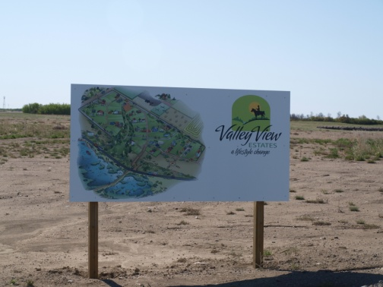
Commercial uses which primarily serve the travelling public shall be encouraged to locate where there is access available from major roadways, including provincial roads and Provincial highways if appropriate. Commercial developments shall be subject to the transportation policies in Section 3.7.

Commercial lot sizes shall permit effective functioning of waste disposal systems, provide separation in order to minimize hazards such as fire and provide an adequate protective buffer to neighbouring uses. Commercial activities that are dependent upon an abundant water supply and which may affect ground water resources need to address water issues prior to locating in rural areas without waterline infrastructure.

The Zoning Bylaw may establish procedures and conditions to ensure commercial development is compatible with surrounding uses, the natural environment and has access to the primary rural transportation network.

Home Based occupations shall be encouraged throughout the district as a valuable contribution to the regional economy. Home-based businesses shall be accommodated provided that they are clearly secondary to the principal residential use of the dwelling unit, are compatible with and do not change the character of the surrounding residential area and are not of a size, scale or use that would affect the viability of established commercial areas.

Industrial Policies

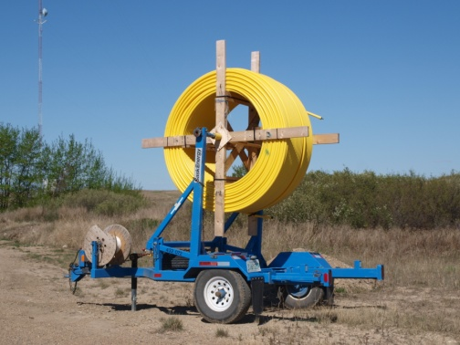
The designation of industrial areas shall be directed to locations that have good access to highway networks access or to the primary rural transportation network. Agricultural and Resource related industrial development may be located in appropriate rural areas. Industrial development shall be concentrated in a minimal number of separate locations or nodes where transportation infrastructure and servicing provision is sufficient for the projected use/intensity and these nodes may provide market benefits by locating an industrial activity adjacent to other complementary enterprises.

The Plan encourages a variety of industrial development which is non-polluting and is complementary to other uses by providing larger lots with limited infrastructure for industrial uses which serve the agricultural, resource extraction or transportation sectors.

Care shall be taken in the siting of industrial and intensive agricultural or natural resource uses that normally create very significant land use conflicts with regard to noise, vibration, smoke, dust, odour or potential environmental contamination. Such uses shall be encouraged to find a location that maximizes separation from residential areas.

A Comprehensive review process will be followed by the Municipality and a Concept Plan shall be completed by any person proposing to rezone, subdivide, or re-subdivide land for industrial development prior to consideration of an application by Council. The review shall be undertaken similar to residential reviews and shall address all matters of land use integration, potential conflict mitigation and the provision of services to the development. Chart “A” in Appendix C provides the development checklist requirements and a sample Development Proposal.

Industrial lot sizes shall permit effective functioning of waste disposal systems, provide separation in order to minimize hazards such as fire and provide an adequate protective buffer to neighbouring uses. Industries or resource extraction like potash that are dependent upon an abundant water supply and which may affect ground water resources will need to address water issues prior to locating in rural areas.

To minimize the encroachment of incompatible lands near landfills, waste management facilities, airports, transportation corridors, rail yards, industrial activities and intensive livestock operations, adjacent lands shall be setback from these existing facilities and any planned future expansion.

Industrial uses exhibiting high potential for conflict with adjacent lands and necessitating distance separation as the sole means of mitigating these conflicts shall be located in isolated areas as required by Provincial regulations. These industries include but are not limited to landfill sites, sewage lagoons, ethanol plants, transformer stations, and anhydrous ammonia storage and distribution centres.

Industrial uses which are likely to be unsightly due to the nature of the industrial operations, exterior storage, or type of building or structures, shall generally be discouraged from locating along the highway approaches and entrance roadways to urban areas. If such uses are proposed in these areas, special landscape buffer or other mitigation measures shall be taken to screen these industrial uses from view.

Where areas are designated for industrial development, the Zoning Bylaw may establish:
- Special limitations and conditions for potentially incompatible uses, including residences, within a specified distance of the designated area; and
- Procedures and conditions to ensure rural industrial development is compatible with surrounding uses and the natural environment.

Industrial developments shall be subject to the transportation policies in Section 3.7.

Hazardous Uses Policies

Hazardous industries shall be required to locate in, or adjacent to, areas of concentrated industrial use.

Hazardous industries must be approved by applicable Provincial and Federal environmental agencies and provide clear evidence of compliance with The Saskatchewan Fire Code, The Environmental Management and Protection Act, The Dangerous Goods Transportation Act, The Fire Prevention Act, the National Building Code, and other applicable codes and standards.

Facilities or developments, which manufacture, handle, store or distribute hazardous materials, will be governed by the following:
- Facilities shall not be located closer to dwellings than permitted or recommended by Saskatchewan Environment;
- Anhydrous ammonia facilities shall be located a minimum of 100 metres from Provincial highways and municipal roadways;
- Where new development or expansion of a potentially hazardous use is proposed, information may be required relating to the nature of any potential discharges into the air, soil or water, the nature of outside storage requirements, the compatibility of surrounding land uses, and plans for buffering such activities from adjacent uses; and
- In instances where the risk is severe, development may be directed to a more suitable rural location.

Emergency Response Planning

Working with adjacent municipalities, the Rural Municipality will be adopting a new working relationship with respect to the development and delivery of Emergency Services.
Objectives
- To prepare a revised regional fire protection and emergency services plan.
- To work with the surrounding municipalities in developing required emergency service infrastructure on a regional delivery basis.
- To ensure that emergency response plans are current and reflect changes in land use or activities.
- To prepare and educate residents in the area on the need for including emergency planning in the day-to -day lifestyle activities.

Emergency Response Policies

Public safety and health requirements shall guide all development. The Rural Municipality shall ensure that emergency and responsive plans are current and reflect changes in land use or activities.

Emergency planning needs to be undertaken before an event to identify risk and to research risk reduction measures that lower the probability of an event even occurring. An understood and practiced plan needs to be maintained.

The Rural Municipality will participate with the adjacent municipalities, in working with existing emergency planning and response agencies in the area. The objective will be to participate in the planning and integration of a regional Emergency Response Plan which is mutually supportive, but reduces unnecessary duplication of resources.

An Emergency Response Plan for the Rural Municipality will be coordinated with all federal and provincial programs and policies and supportive of other urban and rural municipalities within the region.

Wildfire Hazard Areas

Development in wildfire-prairie fire hazard areas should be undertaken with precautions intended to minimize the risk of damage to property caused by wildfires. The objective of the Wildfire Hazard Area is intended to help protect property from the damage of wildfires that may ignite in or around the urban municipalities.

Development should utilize the following guidelines:
- Building sites should avoid steep coulees that may accumulate fire fuel and funnel winds;
- Developers of new subdivisions in wildfire interface areas should consider the integration of trails, roads, and cleared park land around development which may serve as fire breaks, and/or provide vehicle access routes to facilitate fire suppression in interface areas;
- Fuel reduced buffers around homes are encouraged. Integration of a defensible space around a building should include adequate vehicle access, and access to a reliable water supply available to firefighters; and
- Building design and construction shall be generally consistent with the standards of the National Fire Protection Association. (Standard for Protection of Life and Property from Wildfire).

Outdoor Recreational Amenities and Heritage Resources
The Rural Municipality has abundant recreational opportunity and heritage resources and is proud to share these resources with the surrounding communities. The Vale Port Marsh, Meadows area and Last Mountain Historical Site are examples of three of the Municipality’s significant recreational amenities.
Objectives
- To actively promote the Vale Port Marsh as wildlife habitat and riparian areas which should be protected and incorporated with the surrounding development in a complementary manner.
- To promote recreational and cultural opportunities that are available for all ages and lifestyles throughout the Municipality and region.
- To encourage and expand the use of all recreational areas for local and regional residents alike.
- To ensure that all environmental information is provided when new developments and subdivisions are proposed.
- To acknowledge and protect natural areas’ environmental features, and systems within the Municipality.
- To protect significant archaeological, historical, and other cultural sites from incompatible development.
- To prioritize projects that promote local interest and public appreciation of the region’s heritage attributes.
- To ensure adequate recreational and utility space is provided for future needs, through municipal reserves and the provisions of The Dedicated Land Regulations.

Outdoor Recreational Policies

Areas with high recreational capability, interesting and/or rare natural features shall be conserved for outdoor recreation and related uses. All development shall be compatible with recreational development and shall consider the impacts on the Last Mountain Trading Post Historic Site, Provincial and Regional parks and conservation areas such as the Last Mountain Lake trail system, Meadows and old rail beds.

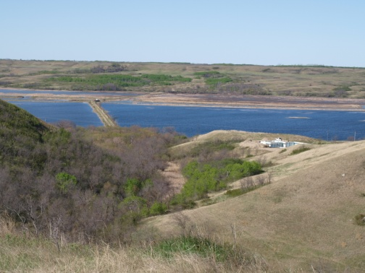
Sites designated Recreational shall be compatible with the existing and adjacent land uses. Land uses and activities adjacent to parks or recreation areas shall be limited to those which would not detract or degrade the primary function from public enjoyment.

Existing outdoor recreational uses and areas shall be protected from incompatible or potentially incompatible land uses, which may threaten their integrity and/or operation.

Proposed recreational developments will be encouraged to carefully match the activity and its intensity to the capability of the land and its ability to sustain the use over an extended period. Proposed recreational development shall not preclude access to and use of public resources (i.e. trail systems).

The Rural Municipality shall work with private sector developers and provincial agencies to encourage and facilitate the development of new, or the renewal of existing recreational facilities and parks to broaden the recreational activities available for residents and visitors to the Municipality.

The Rural Municipality may consider allocating some of its cash-in-lieu funds from the municipal reserve fund for the purposes of assembling and developing regional recreational land and facilities within the region.

Conservation Policies

Developments shall be located and designed to conserve and complement natural areas, contribute to a high quality built and natural environment, and provide welcome benefits to the region.

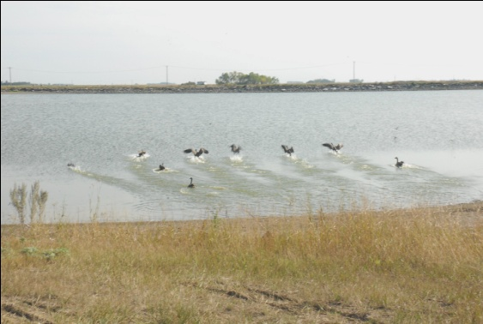
Public access to natural areas and wildlife habitat will be encouraged, where feasible, to foster appreciation for and enjoyment of nature, but such access should not lead to levels of activity which will exceed the capability of the area to sustain the environment and ecosystem integrity. In cases where private lands are involved, access to these areas will be subject to the approval of landowners.

The Rural Municipality will work with Provincial Ministries and agencies to manage:
- Critical Wildlife Habitat and rare or endangered species; or
- Wetlands and sensitive environment.

Natural areas and sensitive environmental areas identified in the Plan shall be protected where development may create potential to stress the environment, by managing these activities in the Zoning Bylaw.

Highly sensitive environment areas or sites with potential for significant heritage resources will be identified to ensure the protection of these resources when these lands may be affected by development. When development is proposed in these areas an assessment of the potential impact on natural and human heritage resources prepared by Heritage Branch or qualified environmental professionals shall be required as part of the development proposal.

Surveys of landscapes, soils, vegetation, and wildlife should be reviewed. If sensitive features are identified (coulees, wetlands, riparian areas) the development shall be modified to avoid these areas. If avoidance is impossible, mitigative strategies shall be developed in consultation with environmental managers.

Natural areas and habitats shall be protected from incompatible or potentially incompatible uses where:
- Rare or endangered flora and fauna have received Provincial designation and protection;
- Lands designated under the Wildlife Habitat Protection Act, and amendments;
- Private lands that have been voluntarily protected by landowners; or
- Lands which may be designated under a variety of other environmental protection legislation or policy.

When reviewing any development proposal, an attempt shall be made:
- To provide for minimum loss of habitat by retaining natural vegetation and watercourses;
- Providing continuous wildlife corridors;
- Conserving habitat for rare and endangered species; and
- Providing landscaping, naturalization or otherwise mitigating the loss of natural habitat where such habitat loss is necessary in the context of a desirable development.

Heritage Resource Policies

The identification of heritage resources shall be encouraged within the district. The Rural Municipality shall work with community stakeholders to identify and assess the importance of natural, heritage sites and areas within the area. At the request of owners, and in accordance with The Heritage Properties Act, 1980, and amendments, significant historic sites and architectural features shall be designated and suitably recognized.

Heritage resources shall be protected where:
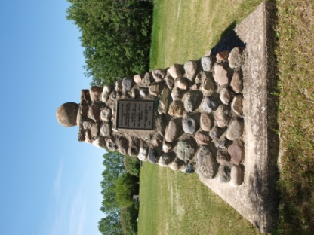
- Buildings or landscapes have received or are in the process of receiving municipal and/or Provincial heritage designation; and
- Buildings or landscapes have been developed and operate as heritage sites.

Existing heritage resources shall be protected from incompatible or potentially incompatible land uses, which may threaten their integrity or operation. Where a land development is proposed in an area of the Municipality that has been identified as a heritage sensitive area or an area containing potential heritage resources, the Municipality will refer the proposal to the Resources Unit of the Heritage Branch to determine if a Heritage Resource Impact Assessment (HRIA) is required pursuant to The Heritage Properties Act.

Municipal and Environmental Reserve

Subdivision applicants will be required to dedicate the full amount of Municipal Reserve owing in the forms provided for in The Planning and Development Act, 2007.

Subdivision applicants will be required to dedicate, as environmental reserve, all lands in an area to be subdivided that can be defined as Environmental Reserve in accordance with the provisions of The Planning and Development Act, 2007, in some instances the approving authority may consider conservation easements in place of environmental reserves.

Where development is proposed adjacent to a watercourse, the Municipality will request the subdivision approving authority to dedicate Municipal or Environmental reserve as appropriate to protect sensitive areas and ensure continued public access to these areas.

Community Services
The Rural Municipality in conjunction with adjacent municipalities is committed to co-ordinate service delivery and to a joint community service initiative where it is mutually beneficial.

Policies

The Rural Municipality will support the development and joint-use of institutional, health, recreational, spiritual and cultural facilities for the benefit of the Municipality and surrounding area.

Residents shall be given the opportunity to pursue community building initiatives with appropriate support and encouragement when planning community services, programs, facilities, neighbourhood environments or other matters that affect their quality of life.
Objectives
- To promote inter-municipal partnerships, public engagement and community based leadership to improve existing institutional services and amenities for residents.
- To cooperate with the adjacent urban municipalities to ensure a full range of institutional, public and community services in areas of education, health and spiritual development are available for the rural residents of the district.

The Rural Municipality will strive to recognize and respond to the need of a growing community and work with various organizations, business leaders, other public institutions, non-governmental organizations, community groups, residents and community volunteers to determine these needs and the best methods to provide and maintain needed community facilities and programs.

The Rural Municipality shall advocate for the planning and provision of services, programs and facilities on a cooperative basis, involving appropriate agencies, groups and individuals to ensure accessible, appropriate, and flexible service provision for all residents irrespective of their physical, economic, social or cultural characteristics.

The Rural Municipality shall work with business, agriculture and industry, non-governmental organizations, community groups, conservation authorities, educational and economic development agencies, other municipalities, First Nations and Métis?, and representatives of other levels of government to:
- Initiate inter-community cooperation to coordinate the efficient provision of services & infrastructure;
- Promote environmentally & economically sustainable developments;
- Stimulate population growth to support social-economic development; and
- Coordinate local and senior government economic and social development initiatives.

Natural Hazard Lands: Flood and Slope Instability
The Rural Municipality is comprised of significant environmentally sensitive lands including sensitive aquifer areas, creeks
and a variety of soils which impact drainage and erosion.
Objectives
- To acknowledge and protect natural, environmental features and systems within the Rural Municipality.
- To identify drainage patterns throughout the municipality.
- To restrict development in areas considered hazardous for development for reasons of ground instability, erosion, flooding, or other environmental hazards.
- To extend the responsibility for sound environmental management to property owners and developers.

General Policies

Natural Hazard lands include the following:
- Lands subject to flooding including all lands which would be flooded by the 1:500 year flood event or in any flood prone area unless the development is above the elevation representing the 1:500 year return frequency flood event and necessary freeboard of 0.5 metres; or
- Lands subject to slope instability or erosion; or
- Lands in areas prone to drainage issues will be based upon historical information and specific site analysis rather than mapping.

Long-term prosperity, environmental health, and social well-being depend on reducing the potential for public cost or risk to residents or properties. Development shall be directed away from areas of natural hazards where there is potential risk to public health or safety.

The Plan identifies areas where natural hazardous conditions may exist to ensure that the developer and/or property owner reasonably assess the hazards relative to the proposed development. See Reference Map.

Development shall be prohibited on lands, which because of their physical characteristics in combination with their location, present substantial risk to property and person. Developers will be required to provide professional, certified environmental, geotechnical, hydrological reports to address development hazards and may require a preliminary analysis by a professional engineer or environmental scientist to identify which hazards may exist in the area of a proposed development. Council may refuse to authorize development of structures on such land or may authorize such developments only in accordance with recommended preventative mitigation measures which eliminate the risk or reduce the risk to an acceptable level and remedial measures.

It may not be practical or desirable for economic or social reasons to restrict certain development in hazard areas. Developments shall, however, be carefully controlled and planned to ensure that they are compatible with the risks or that the hazard has been eliminated or protected against. In these instances, the following criteria shall be applied:
- Proposed developments shall not obstruct, increase or otherwise adversely alter water and flood flows and velocities;
- There shall be no added risk to life, health or personal safety;
- Structures and services must be protected against flood damage and shall be fully functional during hazard conditions;
- Activities which alter existing slopes and may accelerate or promote erosion or bank instability shall be prohibited, unless appropriate mitigation measures are taken to minimize the potential of such erosion or bank instability; and
- Existing tree and vegetation cover shall be preserved where appropriate to reduce erosion and maintain bank stability.

The development of structures on hazard land may be authorized only in accordance with recommended preventative mitigation measures which eliminate the risk or reduce the risk to an acceptable level.

Unstable Slope Area Policies

No new development shall be permitted in any potential unstable slope area without undertaking erosion and/or slope stability investigations to address the interests of the Municipality and to ensure that the developer and/or property owner reasonably assess the hazards relative to the proposed development.

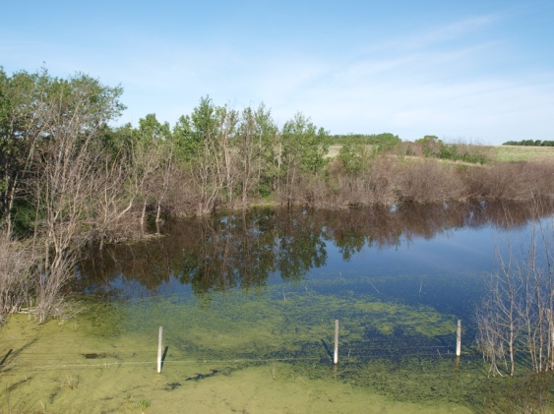
Development and activities shall be avoided where the risk of unmitigated erosion or slope failure exists, where there is the potential to cause erosion or increase the potential for erosion or slope instability on the site or elsewhere, and, when possible, to minimize the potential impacts of slope instability on municipal services and infrastructure.

Developers and property owners shall commission sufficient, professional engineering investigations to reasonably assess erosion and slope failure potential and to understand that they also share in and accept all residual risks and liabilities associated with development where hazard slopes exist.

The Rural Municipality, in addressing the hazards associated with erosion and slope instability shall:
- Require investigations as part of an application for subdivision and/or development;
- Establish the objectives of scientific and engineering investigations in relation to such applications;
- Reasonably ensure, using current and future technical, administrative, and legal means, that the hazards and potential long-term costs associated with potential erosion and slope failure can, and will, be borne fairly by all parties including the proponent and/or the future owner; and
- Ensure that future owners are informed, acknowledge the inherent risks, undertake reasonable investigations, and accept liability for development undertaken on land where slope instability is a concern.

Surface Water and Drainage

Adequate surface water drainage will be required throughout the municipality and on new development sites to avoid flooding, erosion and pollutions. Consideration shall be given to the ecological, wildlife habitat and drainage effects of development, including the upstream and downstream implications.

Where an area has been previously or exhibits potential for poor drainage (sloughs) due to snowmelt or prolonged rainfall events, all proposed building sites shall be located outside of those areas whenever possible. Otherwise, the proponent shall provide a suitable amount of fill at the building site to provide a satisfactory level of protection for the buildings.

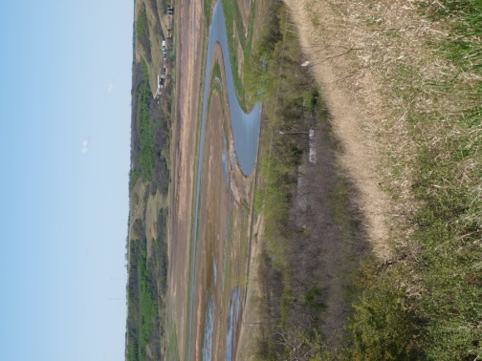
Unauthorized drainage of surface water runoff from any land throughout the Municipality shall be prohibited. Water courses shall not be filled or altered without the prior approval of the Water Security Agency, Ministry of the Environment and the Municipality. The Municipality will be investigating the preparation of an overall drainage plan in the Development Overlay District.

New developments and subdivisions which are adjacent to water courses shall be developed to minimize erosion and to maximize water quality.

Flood Hazard Lands

Development will be restricted in the flood plain to protect against the loss of life and to minimize property damage associated with flooding events. Flood prone lands will generally be limited to agricultural, park and open space recreational uses.

The Water Security Agency or other appropriate government or private sector consultants can be utilized as a source of technical advice regarding flood levels and flood proofing techniques. Development proposals in flood plain areas can be referred to the Water Security Agency for review prior to approval. A site specific legal land survey including contour lines shall be provided by the proponent at the time of a proposed development

The Water Security Agency, may provide comment on (for a fee for work basis where appropriate) whether there is potential for a flood hazard, and if so providing the flood hazard flow. This includes:
- All commercial, industrial and multi-parcel residential subdivisions adjacent to rivers and streams;
- Any Rural Single Residential subdivision where there is no good downstream hydraulic control section;
- Subdivisions adjacent to lakes or wetlands in southern Saskatchewan for which we have no information on the lake bathymetry or outlet characteristics; and
- Where adequate information exists or is supplied, SWA can determine the 1:500 Estimated Peak Water Level (EPWL): the flood level associated with the Design Flood Elevation.
- The safe building elevation for all habitable buildings will be the 1:500 plus 0.5 metre freeboard.

Implementation and Action Plans

Plans are only as good as their implementation. These Action Plans provide guidance and a framework for ongoing dedication through municipal influence and community engagement to fulfill this Plan’s objectives.

Making Things Happen
Successful implementation of this Plan depends to a large degree on whether its policies can guide local development and action in a variety of contexts over the next fifteen to twenty years. This Section contains policies to ensure that planning is sensitive to local conditions in specific locations of the Municipality, while at the same time advancing the Plan’s core principles and building on its broad objectives.
To achieve the goals set out in this Official Community Plan, a clear plan of action or implementation strategy is required. The following tables have been included to provide a checklist of the key action items that will need to be completed to help the Municipality achieve its goals outlined in the Plan. Each action item relates to policy statements included in the Plan and will require an Implementation Committee of Council to be established to prioritize the action items. The action items should be reviewed regularly to monitor progress and to determine if changes are required.

The Plan Guides Action


As a statutory document for guiding development and land use in the Rural Municipality, the Plan gives direction to Council on its day-do-day decision making. The Plan’s land use policy areas illustrated in the Future Land Use Plan “Appendix A” provides geographic references for the Municipality’s policies. If the Municipality is to move closer to the future envisioned by the Plan, the Plan must guide other related decisions of Council. The Planning and Development Act, 2007 requires that:
- Municipal bylaws and public works will conform to this Plan;
- The decisions and actions of Council and Municipal Administration, including
public investment in services, service delivery and infrastructure, will be
guided by this Plan; and
- Implementation plans, strategies and guidelines, consistent with this Plan will be adopted, identifying priorities, detailed strategies, guidelines and actions, to advance the vision, goals and objectives of this Plan.

The Future is a Shared Responsibility

A community is successful when all sectors cooperate with their time, effort and resources to enhance the quality of life in the greater community or district. The Municipality can lead by example with engaged and informed residents to successfully guide the future, measured by the accomplishments made in managing agricultural diversification, environmental stewardship, economic development, community service provision, population growth, and the overall lifestyle available in the Municipality. To achieve the goals and objectives of this Plan, the Rural Municipality of Longlaketon will advocate for provincial partnerships and technical assistance to deliver services and programs for sustainable agricultural, economic, and community development.

Community Development
IMPLEMENTATION
Action Item | Time Frame | Key Participants
Develop an Action plan for the Municipality to organize community development initiatives
Prepare a new Fire Management Plan and Emergency Response Plan for the Municipality and the surrounding municipalities
Provide support for a regional tourism strategy in conjunction with the Town of Earl Grey and the Villages of Craven and Silton and prepare a regional recreational strategy with the adjacent Municipalities.

Land Use Planning
Land Use Planning
IMPLEMENTATION
Action Item | Time Frame | Key Participants
Set up administrative procedures for review and amendments to the Official Community Plan
Review Subdivision/Development Fees and Servicing Agreements on a regular basis
Explore Regional Waste Management opportunities with adjacent Municipalities
Research Revenue/Tax Sharing opportunities for collective service provision
Explore option of appointing an Inter-Municipal Development Appeals Board
Establish an up-to-date mineral extraction policy (sand, gravel and soil)

Residential Options
Land Use Planning
IMPLEMENTATION
Action Item | Time Frame | Key Participants
Regularly review residential policies

Environmental Management

IMPLEMENTATION
Action Item | Time Frame | Key Participants
Prepare a regional drainage plan
Investigate alternate waste disposal options

Transportation Planning
Land Use Planning
IMPLEMENTATION
Action Item | Time Frame | Key Participants
Review and reaffirm road infrastructure plan yearly

Inter-Jurisdictional Cooperation

Introduction

Development pressures exist on the lands adjacent to the many urban Municipalities located in the Rural Municipality of Longlaketon. While these developments have potential benefit for all Municipalities, there is concern that servicing and development standards be applied consistently. There is need to encourage orderly and timely development on the fringe areas to ensure that all future development potential or servicing needs are not compromised and that boundaries can be altered if required to address these needs.

The Rural Municipality of Longlaketon will continue to work with other adjacent municipalities, First Nations and Métis with regards to matters of Land Use Planning and Development.

Inter-Municipal Cooperation

Inter-Municipal agreements shall be pursued to ensure that local and regional growth issues are addressed proactively. A coordinated, integrated and comprehensive approach shall be used when dealing with planning matters within the Municipality, or which cross municipal boundaries, including:

- Managing and/or promoting growth and development;
- Managing natural heritage, water, agricultural, mineral, and cultural heritage and archaeological resources;
- Infrastructure, public service facilities and waste management systems;
- Ecosystem, shoreline and watershed related issues;
- Natural and human-made hazards; and
- Population, housing and employment projections, based on regional market areas.

The Rural Municipality shall pursue partnerships with all the municipalities to minimize potential land use conflicts for existing and proposed uses on the undeveloped lands adjacent to the Towns and Villages.

Consultation is a key component of the Inter-municipal cooperation policy and it is expected that all jurisdictions will incorporate realistic growth and land use requirements in their respective OCPs and that they be reviewed with input from the North Valley Inter-Municipal Organization.

The Rural Municipality will cooperate to ensure that development and land use patterns which are adjacent or in proximity to urban areas that may hinder a Town’s expansion will be discouraged, or mitigated. This does not apply to such effects that arise in the course of normal, non-intensive farm operations. The Rural Municipality will ensure that this area will be protected from incompatible growth by requiring a comprehensive development proposal (refer to Chart “B” in Appendix C) that will be jointly reviewed by the Communities of Earl Grey, Silton and Craven and lands adjacent will be identified with compatible future land use designations.

Inter-Municipal cooperation and public/private sector initiatives that focus on a cooperative approach to providing cost efficient services that optimize the Municipality’s financial and infrastructure resources shall be encouraged. The capital works program and public improvements are an important implementation tool for municipalities and actions by one Municipality may influence the location of future development and growth through the provision of municipal services to land in an adjacent municipality.

Revenue Sharing

Inter-Municipal revenue sharing and other agreements to equitably share costs and benefits of future development in the region shall be encouraged.

Revenue sharing shall be explored where there are significant opportunities to promote and enhance development and growth within the region by working together in a cooperative manner, when any “regional type” business or development is considering this region that will provide benefit to a number of individual Municipalities. All tax-sharing arrangements will be negotiated on fair and equitable basis with respect to: recovery of capital investment, land use development standards, and negotiating compatible servicing agreements.

Annexation

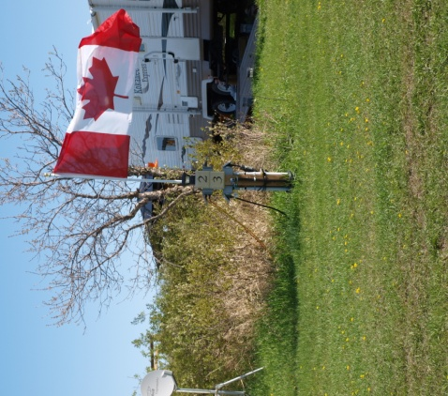
The periodic need for urban expansion through the annexation process should be consistent with the provisions and intent of this Plan and the annexing Municipality. Annexation shall be undertaken in a positive, orderly, timely and agreed-upon process where there is a clear and present need and development is expected to occur within a five (5) year period. Municipalities should avoid a large and complex annexation in favour of annexations involving smaller amounts of land occurring on an as-needed basis.

Where it is necessary to expand the boundaries of an existing urban municipality, community expansion should occur on a logical basis and should be well-integrated with the existing community structure and directed away from large acreages of prime farmland and livestock operations.

The need for community expansion should address the timely conversion of rural land for urban expansion in areas adjacent to urban municipalities in order to protect existing rural land uses from premature conversion to urban forms of development where the timing of urban expansion is uncertain. Annexation shall follow legal boundaries or natural features to avoid creating a fragmented pattern of land ownership and should, as much as possible, have support from the current landowners involved.

The Rural Municipality will develop a coordinated approach with urban municipalities for future boundary expansions in order to ensure consistent planning, cost effective and efficient service delivery and good governance for residents on the municipal fringe.

Development and land use patterns which are adjacent or in proximity to urban areas that would hinder the expansion of these areas, or which may have negative effects on future urban design and / or densities, will be discouraged. As stated in the inter-Municipal Cooperation policy, the Rural Municipality will ensure that areas around the urban centres will be designated for complementary development and it is expected that all municipalities will consult with each other prior to any annexation. As stated, the lands adjacent to all urban communities will be protected through the Plan policy and where development is proposed in these areas of the Rural Municipality, it must be compatible with the urban municipality’s demonstrated growth needs.

In the event of annexation where land is not currently serviced, the Town or Village may enter into an agreement to compensate the Rural Municipality for the existing municipal portion of property taxes on a descending scale. The annexation should not dramatically alter the taxes collected from agricultural lands in the annexation area simply because of annexation. Where annexation involves existing developments such industrial or commercial tax-loss compensation will be determined based on currently accepted rates.

Treaty Land Entitlements and Specific Claims AND DUTY TO CONSULT

Where land within the Municipality has been purchased by a First Nations Band and it is pursuing “reserve” status through either the Treaty Land Entitlement process or the Specific Claims process, the Municipality will encourage compatible development. Council will offer to meet with the Band Council of the First Nation to discuss, and if possible, negotiate shared services, compatible bylaws and other matters of mutual interest.

Council shall encourage the Band Council to enter into an agreement (Memorandum of Understanding) with the Municipality to achieve complementary Band Bylaws by adopting a Land Use Code or other land use Bylaws similar to the provisions of the Rural Municipality of Longlaketon’s Official Community Plan and Zoning Bylaw, as well as to achieve continuity or the sharing of public services.

Administration

Planning Tools
This Section outlines the variety of traditional tools Municipalities have available to make things happen. The Planning and Development Act, 2007 provides the authority that governs plans of subdivision, zoning bylaws, servicing agreements, development levies and review processes to ensure that the Plan is effective over the long term.

Definitions
The definitions contained in the RM of Longlaketon’s Zoning Bylaw shall apply to this Official Community Plan.

Adoption of the Official Community Plan
Adoption of this Official Community Plan by the Rural Municipality will give it the force of law. Once adopted, no development or land use change may be carried out within the area affected by the Official Community Plan that is inconsistent or at variance with the proposals or policies set out in the Official Community Plan.
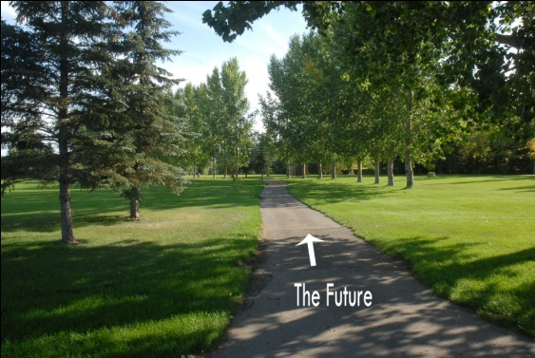
By setting out goals, objectives, and policies, the Official Community Plan will provide guidance for the Rural Municipality in making decisions regarding land use, zoning, servicing extension, subdivisions and development in general. These decisions must be made in conformity with the stated objectives and policies to ensure that the goals for the future development of the Municipality will be achieved.
The application of the Official Community Plan policies is illustrated in the Future Land Use Plan contained in “Appendix A.” This Plan is intended to illustrate the locations of the major land use designations within the Rural Municipality of Longlaketon. This “map” should not be interpreted in isolation without consideration of the balance of the Official Community Plan. The Land use designations have been determined by a number of factors including existing patterns of land use, projected land needs, resource areas, natural attributes and man-made features.
The Official Community Plan will be implemented, in part; by the development-related decisions that will be made in the future; however, the two most important tools available for guiding the future development of the Municipality are the Zoning Bylaw and the subdivision process, including associated agreements.

Adoption of Municipal Zoning Bylaws
Following the adoption of the Official Community Plan, the Rural Municipality of Longlaketon is required to enact a Zoning Bylaw which will set out specific regulations for land use and development:
- The Zoning Bylaw must generally conform to the Official Community Plan and future land use and development shall be consistent with the goals and objectives of this Plan;
- Future development will avoid land use conflict and meet minimum standards to maintain the amenity of the Municipality;
- Zoning Bylaws designate areas for certain types of development. Permitted and discretionary uses and development standards are prescribed for each zone.
- Development will be consistent with the physical opportunities of the land and of reasonable engineering solutions;
- Undue demand shall not be placed on the Municipality for services, such as roads, parking, water, sewers, waste disposal, and open space;
- The objectives and policies in the Official Community Plan provide guidance to Council when preparing the Zoning Bylaw or considering an amendment to the Zoning Bylaw.

The Zoning Bylaw will be used to implement the policies and achieve the objectives of this Plan by prescribing the uses of land, buildings or other improvements that will be allowed in the different zoning districts established in the Municipality. In addition, the Zoning Bylaw regulates how these uses may be carried out and the standards that developments must meet.
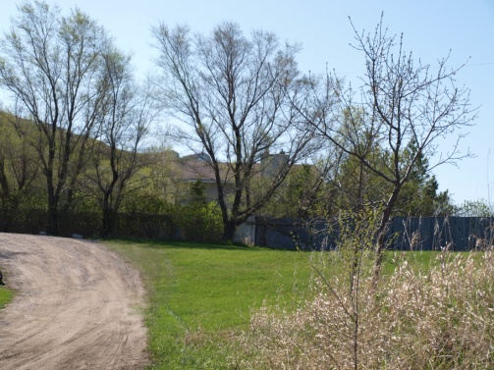
The Zoning Bylaw provides the Rural Municipality with actual control over land use and the types of development and uses allowed in each land use district. The associated supplementary requirements and development standards will be specified in the Zoning Bylaw respecting building setbacks, parking, loading, landscaping, signage, buffering and all other relevant standards prescribed by the Rural Municipality.
To ensure that these regulations work to help achieve the stated goals and objectives, the Bylaw itself must be consistent with the policies and the intent of this Plan. In considering a Zoning Bylaw or an amendment, the Municipality should refer to the policies contained in the Plan and the “Future Land Use Plan” (Appendix A), to ensure that the development objectives of the Municipality are met.

Contract Zoning, Direct Control Districts and Planned Unit Development
For purposes of accommodating a rezoning for unique development situations, Council may consider entering into rezoning agreements, pursuant to contract zoning provisions of The Planning and Development Act, 2007, for site specific development based on the following guidelines:
- The rezoning to permit the development will not unduly conflict with adjacent land uses that are legally permitted uses within the proposed or adjacent zoning district;
- The rezoning will be used to allow a specific use or range of uses contained within the zoning district to which the land is being rezoned;
- The development or redevelopment of the site for the specific use will be of benefit to the immediate area and the Municipality as a whole.
- The use of these zoning tools does not undermine the intent of the Plan or any affected legislation such as The Condominium Act or Environment or Health regulations.

Direct Control District
In accordance with The Planning and Development Act, 2007, where it is considered desirable to exercise particular control over the use and development of land and buildings within a specific area, Council may, in the Official Community Plan and Zoning Bylaw, designate an area as a Direct Control District.
Direct control districts (DCDs) are intended to provide for developments that, due to their unique characteristics, innovative approaches or unusual site constraints, require a more flexible approach to land use regulation than is available under traditional zoning. DCDs are likely to be applied to small or irregularly shaped lots, lots restricted by physical barriers or existing commercial or industrial areas where comprehensive redevelopment schemes are required in order to ensure proper and desirable development
Criteria utilized in the evaluation of development in DCDs shall include, but not be limited to the following:
- The development shall provide for a reasonably compatible interface with adjacent land uses and development;
- the development shall be designed in a manner which will address applicable environmental concerns (i.e. noise, pollution);
- The development shall meet the goals and objectives of the relevant section( s) of this Plan; and
- The development shall provide for adequate off-street parking and loading facilities, as well as special considerations for site layout and landscaping.

Planned Unit Development Use of Contract Zoning
The purpose of the Planned Unit Development Contract Zoning is to allow diversification in the relationship of the various uses and structures to their sites and to permit more flexibility in the use of such sites. The application of planned unit
concepts are intended to encourage good neighbourhoods, housing, or area design securing the advantages of site planning for residential and commercial use.

Planned Unit Development means an integrated design for development of residential and commercial uses, or a
combination of such uses, in which one or more of the regulations, other than use regulations, of the zone in which the development is to be situated, is waived or varied to allow flexibility and initiative in site and building design and location in
accordance with an approved plan and imposed general requirements. A Planned Unit Development may be:
- the development of compatible land uses arranged in such a way as to provide desirable living environments that may include private and common open spaces for recreation, circulation, and/or aesthetic uses;
- the conservation or development of desirable amenities not otherwise possible by typical development standards; and
- the creation of areas for multiple use that are of benefit to the community.

Concept Plans
Concept plans are reference plans, not policy plans. They represent design layout concepts prepared at the request of the Municipal Council to provide direction for how new developments:
- Ensure the efficient provision of infrastructure services;
- Demonstrate how site development will be organized to ensure compatibility with adjoining land uses and transportation systems; and
- Provide design features for special purposes such as landscaping, buffers, open space, pedestrian and vehicular access.

Comprehensive Development Proposals


A Comprehensive Development Proposal shall be completed by the planning staff prior to presenting it to Council, on behalf of any person proposing to rezone, subdivide, or re-subdivide land for multi-parcel country residential, commercial or industrial purposes. The purpose of this comprehensive review is to identify and address social, environmental, health and economic issues appropriately and to encourage the development of high quality residential, commercial, and industrial developments. This review proposes to address the following topics:

  - Proposed land use(s) for various parts of the area;
  - The effect on adjacent land uses and integration of the natural landscape regarding the planning and design of the area;
  - The location of, and access to, major transportation routes and utility corridors;
  - The provision of services respecting the planning for future infrastructure within the Municipality;
  - Sustainable development and environmental management practices regarding surface and groundwater resources, storm water management, flooding and protection of significant natural areas;
  - Appropriate information specific to the particular land use (residential, commercial or industrial); and
  - Proponents may be required to undertake and submit special studies as part of the approval process for certain types of development proposals. Engineering or other professional studies may be required including traffic studies to determine impacts upon the Municipality’s road and highway system, assessments of lands affected by flooding or slope hazards, endangered species, heritage resources, potential for ground and surface water pollution, and general risk to health and the environment.
  - A sample submission is contained in Appendix C titled “Berlin Developments.”

Existing and Non-Conforming Uses
Where land use is designated in the Plan which differs from existing use, the existing use will be allowed to continue as a non-conforming use. However, any redevelopment of the parcel of land or expansion of the conforming use will be required to comply with the land use designated in the Plan, unless otherwise approved by Council under the provisions for non-conforming uses in the Zoning Bylaw.

Development Levies and Agreements
Council may provide for a Development Levy Bylaw as specified in Sections 169 to 170 of The Planning and Development Act, 2007. Where a development is proposed that is of a greater density and requires the capital upgrading of services beyond those originally provided for in the subdivision of the land, Council may by Bylaw, provide for the recovery of those capital costs.
Council may adopt a Bylaw that specifies the circumstances when these direct or indirect levies will apply to the development based on the additional capital costs for services created by that development. The Bylaw will contain a schedule of the unit costs to be applied. Before adopting the Bylaw, Council will undertake studies necessary to define the benefiting areas and the unit costs associated with required capital upgrading of off-site services. The studies will be used to determine a fair level of development levy charges in relation to the subdivision fees.

Servicing Agreements
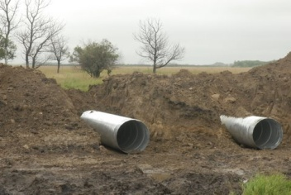
Council may establish fees for the collection of subdivision servicing charges that would be applied in a servicing agreement at the time of subdivision in accordance with Section 172 of The Planning and Development Act, 2007, to ensure that new subdivisions are developed to the standards of the Municipality and to address other concerns specific to the proposed subdivision. Where Council requires a Servicing Agreement, the Agreement becomes a condition of approval of a subdivision by the approving authority. The Agreement will ensure that municipal standards are met for capital works and ensure that such infrastructure development costs are borne by the developer and his/her customers. A Servicing Agreement will be required by all subdivision proponents. The requirements, conditions and fees may vary depending upon service needs.
As an example: “Where a subdivision of land requires the installation or improvement of municipal services such as waterlines and sewage systems, streets or walkways within the subdivision, the developer will be required to enter into a Servicing Agreement with the Rural Municipality to cover the installation or improvements including, where necessary, charges to cover the costs of improvement or upgrading of off-site services, such as the Municipality’s water treatment plant. Council will, by resolution, establish the standards and requirements for such agreements and charges, including the posting of performance bonds or letters of credit.”

Subdivision Process
The Director of Community Planning for the Ministry of Government Relations is currently the approving authority for subdivisions in the Rural Municipality of Longlaketon. The Municipality has input into the subdivision procedure:
- The Municipality provides comments on all subdivision applications within the Municipality;
- The Municipality has an impact on the subdivision process through the Zoning Bylaw, since no subdivision can be approved that does not conform to the Zoning Bylaw. In the Zoning Bylaw, the Municipality can establish the minimum area, width, or depth of lots, and other spatial and land use standards. Zoning is intended to implement the Rural Municipality’s development policies, and to ensure that subdivisions contribute to achieving the long term goals of the Municipality; and
- In order for the subdivision to be completed in a timely manner, it is advisable to consult with the planning staff of the Municipality before submitting a subdivision proposal to Government Relations.

Monitoring Performance

Review
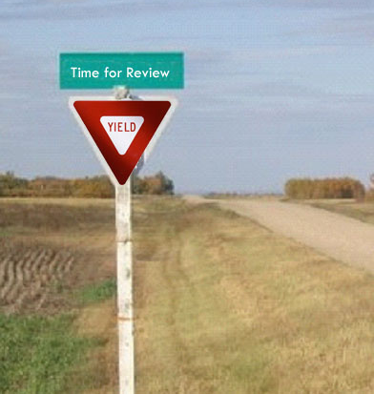
The Official Community Plan is a document intended to guide decision making over the long term and is not a static document that commits the Municipality to an inflexible development policy. As new issues and concerns arise, or old ones change, the Plan shall be revised to meet these changes. The "Plan" shall be reviewed after five years and before ten years from the date of its adoption by Council to evaluate the stated goals, objectives and policies as to their relevancies.
The Official Community Plan must be kept up to date to ensure that the document will deal with the real development issues facing the Rural Municipality and the greater community. New implementation initiatives will be needed and priorities will require adjustment in response to the varied and changing conditions in the Municipality.

Amendment

On occasion land uses or developments may be proposed that do not conform to the Official Community Plan. The Plan can be amended in accordance with The Planning and Development Act, 2007, to allow the new development to proceed, however, before any amendment is made, the impact of the proposed change on the rest of the Plan and the future development of the Municipality shall be examined. Any changes to the Plan or the Zoning Bylaw shall be in the interest of the future development of the community as a whole. Through periodical review and amendment the Plan should serve as an effective guide for Council to make decisions on the future development of the Municipality.

Repeal and Effective Date of Bylaw

REPEAL

All Land Use Bylaws shall be repealed upon approval of Bylaw 5-2013 the Official Community Plan, coming into force and effect.

MINISTERIAL APPROVAL

This Bylaw is adopted pursuant to The Planning and Development Act, 2007, and shall come into force on the date of final approval by the Minister of Government Relations.

COUNCIL READINGS AND ADOPTION

 |  | day of
Read a first time this |  |  |  | 2013
Read a second time this |  | day of |  | 2013
Read a third time this |  | day of |  | 2013

______________________________
REEVE

______________________________
ADMINISTRATOR

_ _
Tim Cheesman, MCIP, P.Ag
Professional Planner

Appendix “A” Future Land Use Plans

Appendix “B” Reference Maps

Map 1: Recreational Amenities

Map 2: Utilities

Map 3: Transportation

Map 4: AGRICULTURAL POTENTIAL

Map 5: ENVIRONMENTALLY Sensitive Areas

Map 6: AIRPHOTO MOSIAC

Map 7: Shaded Relief WITH Drainage
MAP 8: LAND COVER TYPE
MAP 9: INTENTIONALLY BLANK FOR FUTURE MAP ON HERITAGE RESOURCES
MAP 10: POTASH DISPOSITION MAP

Appendix “C” Development Review Criteria

Chart A: Development Review Criteria
- When considering applications to rezone, subdivide, and develop land, Council shall have regard to the following concerns:
• Conformity with the plan goals, objectives, and policies, and the zoning bylaw development standards;
• The viability and necessity of the proposed use;
• The degree of prematurity (e.g., time, location, servicing, cost, municipal capabilities, etc.);
• The availability of alternative sites and buildings to accommodate the proposed development to achieve the intent of this Official Community Plan and the Zoning Bylaw;
• The ability of the Rural Municipality to provide the required public utilities and to enter into suitable servicing and development agreements, to ensure the costs do not outweigh the benefits to all parties concerned;
• The compatibility and suitability of the proposed use with nearby land uses, existing and preferred public utilities, the character of the area, and the environmental protection goals, objectives, and policies;
• The effect of the proposed development on proposed municipal projects identified in this bylaw, including municipal reserve and recreational policies;
• The effect compatibility and suitability of the proposed development on any wildlife habitat, heritage or archaeological sensitive area. Where a proposal is located within an identified environmentally sensitive area consultation with appropriate departments and agencies is required to ensure effective environmental management; and
• Any additional reports, studies, development issues, resident concerns, provincial comments, and public hearing submissions.
- Prior to the consideration of a development or subdivision proposal, the council may require an area Concept Plan be prepared. Where a Concept Plan is considered necessary, the plan will consider the following:
• The location of proposed uses in relationship to adjacent and surrounding uses;
• Servicing requirements of the proposed subdivision or development (water quality and quantity, sewage disposal, fire fighting capability, utilities);
• The types of developments proposed;
• Access, and the potential impacts on the road allowance, highway, road, or trail system and traffic safety;
• The agricultural capability of the soils;
• Existing and future uses in the surrounding area;
• Development standards or design criteria which includes such aspects as parking, disturbance of land, reclamation, landscaping, screening, storage, signage, and building design and finish; and
• Any other matters which the Rural Municipal Council considers necessary.
- Subdivision and development proposals shall not be approved where the proposal:
• Is detrimental to the health, safety, convenience, or general welfare of the persons residing or working in the area;
• Is injurious to, or incompatible with, existing or proposed developments or public utilities in the vicinity;
• Involves, in council's opinion, prohibitively expensive public utility construction or municipal maintenance and reclamation costs;
• Involves the refusal of a developer to enter into a servicing or development agreement; and
• Is not located, appropriately arranged or serviced on an environmentally protected site or in an environmentally suitable manner.

Chart B: Sample Development Proposal “Berlin Developments”

BERLIN DEVELOPMENTS LTD.
Proposes
HEIDELBERG ESTATES
MULTI-PARCEL DEVELOPMENT
A Complementary Phase of Hamburg Estates Phase IV
Submission
Prepared for Rural Municipality of Longlaketon No.158
HEIDELBERG ESTATES MULTI-PARCEL DEVELOPMENT

INTRODUCTION
This report is intended to express our client's interest in developing a quality high-density country- residential development within the Rural Municipality of Longlaketon No. 219. This development would consist of the Development of Lot 1 of Block 2 of the NW XX-XX-XX-W2nd, to provide a total of 44-45 new residential sites within a planned unit development under condominium ownership on a 20 acre parcel.
In 1994 Berlin Developments Ltd. initiated a country residential proposal known as Hamburg Estates. That initiative was proposed in response to a perceived need in the market place for high-end country living. To date this development is over 80% sold.
Throughout the development process of the country-residential acreages, many clients expressed strong interest in a rural adult oriented residential condominium project which would complement the rural acreage development by Berlin Developments Ltd.

PROPOSAL SUMMARY
This initiative proposes to develop subdivided Lot 1 of Block 2 which is 20 acres into 44-45 single residential dwelling units in a planned unit development under condominium ownership. The market targeted would be adult oriented, with housing in the neighbourhood of $300,000 - $400,000 per unit. However, marketing will not be limited to this cross-section of the market as the need for even more affordable quality homes is recognized by Berlin Developments Ltd. Development control guidelines would be in place to address construction deadlines, minimum square footage, fencing, architectural controls, and other measures as deemed appropriate as in all Berlin Developments Ltd. A full provision of services is proposed, including surfaced internal roads, utilities and other amenities as required by this market. This would involve the provision of full water service, along with off-site waste management, a landscaping and drainage plan, lighting, common grounds, facility development, garbage removal, and all other amenities common to similar development in adjacent urban centres.
With the exception of an increase in traffic on XXXX Avenue, little demand will be added to municipal services. Impacts of development are minimized by the following:
- Water connection would be to the existing RM of Longlaketon Low Pressure water line (subject to RM approval);
- Development of a sewage lagoon and sewage removal system would be undertaken and maintained by the developer;
- Power, gas and telephone lines exist in close proximity to the proposed sites;
- Internal roads would be surfaced, built to municipal standard; and
- The proposed subdivisions are on the existing garbage collection and haul route and convenient for similar solid waste removal weekly as in the adjacent urban centres.

Development of the residences and site would be undertaken by Berlin Developments Ltd.

MARKET ASSESSMENT
Within the White Butte region there exists a sizeable population of the upper income 55+ age group. Within this group there exists considerable demand for country living experience. However, this group is not willing to forego the conveniences of urban amenities and expects a higher level of service than the rural acreage resident. The large numbers of individuals who have expressed interest in this type of development are those who either feel that a rural acreage home requires too much work or are dissatisfied with high density urban condominium developments.
Developments catering to this market must combine a country residential atmosphere with the high level of amenities required. These amenities include quality potable water and sewage handling, good local roads, a sense of community, local natural amenities and space, while at the same time in close proximity to the City, all amenities presently provided for in Hamburg Estates.
The minimum 50' x 110' individual parcel size has been selected primarily in response to market demand and experience with urban developments. Second only to the level of services offered, the lot size is the second most important consideration for those interested in country residential living. The response by this age group has created a demand for a large enough lot to provide a minimum 1,200 square foot bungalow with garages for vehicle R.V. parking area while retaining a manageable individual yard for landscape and patio amenities.
Target Market:
Upper Income 55+ Age Group
Another aspect of this market is a strong preference for a 'sense of community', which is even stronger than in the previous Hamburg Estates Developments. Subdivisions that project a sense of community tend to sell quicker, experience a significantly slower turnover rate, and are generally better maintained properties.
Given these market characteristics and continued rural housing demand, it is important to note that this location has proven to be extremely attractive. No other rural residential developments exist that offers such an appealing location close to the City, adjacent to urban centres, golf courses, medical facilities, recreation and shopping, etc.

PROPOSED IMPROVEMENTS
The following development controls and improvements are proposed for this development:
- Potable water will be provided through a connection to Municipal water;
- Sewage will be handled by an internal collection system with an off-site lagoon to be maintained by the developer and located the appropriate distance as per Saskatchewan Health and Sask Environment regulations;
- Internal roads will be Surfaced or Double chip sealed and built to municipal standard and will include individual access;
- Each individual building parcel will be serviced by power, natural gas, telephone, and cable;
- Architecturally controlled fencing will be installed required around the property;
- Landscaping and common recreation and amenity space will be done by Berlin Developments Ltd. which will accentuate the rural feeling and also provide a common recreation centre and games area;
- Surfaced R.V. parking; and
- Minimum dwelling size shall be as follows:
TABLE C2A: MINIMUM DWELLING SIZE

HOUSE TYPE | PHASE"
Bungalow | 1,200 Ft²
Bi-Level | 1,200 Ft²
Split | 1,200 Ft²
Two-Storey | 1,600 Ft²

- All housing will be single detached dwellings, architecturally controlled;
- All dwellings will feature a minimum two car attached garage;
- Vinyl siding or stucco will be a minimum requirement; and
- Accessory buildings will require Developer approval.

PROJECT PHASING
TABLE C2B: PROPOSED DEVELOPMENTS
(Subject to Official Community Plan and Zoning Bylaw Review and Amendments)

DEVELOPMENT PHASE | PROPOSED DATE
Development Approval | Summer 2010
Lot Sales | Post Approval
Road Grading/Street Surfacing | Summer 2010
Power, Natural Gas (to each lot) | Summer 2010
Water Connections | Summer 2010
Sewage Lagoon and System Construction | Summer 2010

The cost of tying each residence into power and natural gas, water and sewer and cable and telephone will be included in the purchase price.

IMPACT ASSESSMENT
It is anticipated that given the location, proximity to amenities, and services, impact to the Rural Municipality of Longlaketon No 158 and adjacent land owners will be positive, as the hard surface road development on XXXX Avenue has mitigated concerns over dust and improved adverse weather road conditions.
The parcel of land involved is Class 4 land. This land has severe limitations that restrict the range of crops that can be grown. This is primarily due to the sandy structure of the soil. Much of the land proposed is covered with poplar and aspen bluffs, which are ideally suited to country residential development and in fact will be incorporated in the design.
In addition, Berlin Developments has recognized the need to utilize land efficiently and the negative impact of consuming large tracts of rural land. Therefore, it was felt that this concept would utilize part of an existing developed area. We also recognize the innovative concept will require a review of the existing Official Community Plan and Zoning Bylaw provisions. In addition, we recognize the need to participate in public consultation with all affected stakeholders and the adoption of a structure and / or concept plan for the area.
The proximity to major amenities for this market niche is excellent, as several golf courses are located nearby - along with proposed on-site recreational amenities in a country setting, and convenient surface access to Highway No. 1 and Hwy 46 and the City.
It is anticipated that XXXX Avenue will carry the vast majority of traffic from the residential development. The convenience of using XXXX Avenue to Heidelberg Estates households is anticipated to be high, given the short travel distances involved and the route's superior road design and snow removal services.
The developers will be building the residences to ensure quality and compatible development. Development would occur within one year, thus ensuring an orderly and timely rate of development.
Any required municipal servicing and development agreements will be entered into in order to clearly define areas of responsibility.
Any municipal reserve requirements will be addressed to the Rural Municipality. In addressing the Official Community Plan requirements, the following separation distances and uses have been respected, including separation from:

- Intensive livestock operations;
- Hazardous industry;
- Rural industrial zone;
- Sewage lagoon sites; and Solid waste disposal sites.

No development will be allowed on lands with:

- High aggregate potential;
- Designated as conservation areas;
- Significant wildlife habitat;
- Cultural or historic significance;
- On environmentally sensitive areas;
- High agricultural capability; and
- Natural Hazard conditions.

MARKETING STRATEGY
Berlin Developments Ltd. will use its proven marketing strategy which consists of:
- A prominent sign on the corner of the development;
- A sales office will be open adjacent to Berlin Developments’ principal residence. The sales office/show room will be staffed from 1 p.m. to 5 p.m., seven days per week during peak seasons;
- A visual rendering in the show home will outline the proposed development in its fully developed stage;
- Brochures and advertising as in all Berlin Developments;
- Individual signs will be erected on site indicating relevant information;
- Financing for individual purchasers will be made available;
- A broad promotion campaign involving television, radio and print media will continue;
- Sales would be open to members of the area Real Estate Board’s multiple listing service; and
- Refunds will be provided if construction is not initiated within one year.

LAND USE POLICY AND ZONING IMPLICATIONS
It is recognized that this development scenario is new to the RM of Longlaketon; however, similar developments have been undertaken around the Cities of Saskatoon, Winnipeg and Calgary. This particular development would require amendments to the policy plan; however, the basic intent of accommodating multi-parcel residential uses would seem compatible. The issue of densities and site sizes would require change. This development would be ideally suited to the use of 'Direct Control District' or 'Contract Zoning' provisions. As in other developments, a suitable contract zoning, servicing, and development agreement could be developed to protect all parties.
The condominium ownership issue should not affect land use considerations, however, would serve to enhance the option for an 'organized hamlet' process for the Hamburg Estates area. The concept of providing higher density and high recreational amenity development, while at the same time retaining a rural emphasis, is not inconsistent with the multi-parcel higher density provisions of the Official Community Plan.
In addition, by incorporating this proposal into an existing development, it would not be inconsistent with separation distance provisions.

SERVICING COSTS
Servicing costs have been prepared and illustrated below in both summary and detailed formats. The cost estimate was based on the assumption that the water supply system would entail the construction of a distribution system connected to the Municipal water service on XXXX Avenue presently ending at the Hamburg Estates, and the construction of an entirely independent sanitary sewer system with the acquisition of land for a sewage lagoon, north of the development.
The servicing costs reflect the expected level of service for such a development. Landscaping plans and costs have not been included in the proposal at this time as the layout will be modified to address the natural environment.

Table C2C: Summary Cost Estimate
WATER DISTRIBUTION | $70,760.00
SANITARY SEWER | $62,320.00
SANITARY FORCEMAIN & LIFT STATION | $94,240.00
BUILDING SERVICES | $40,370.00
WATER SUPPLY LINE | $95,000.00
SEWAGE LAGOON | $230,000.00
ROUGHGRADING | $14,700.00
ROAD CONSTRUCTION | $148,830.00
UTILITIES (TELEPHONE, ELECTRIC, GAS) | $99,000.00
STREET LIGHTS | $22,400.00
SUB-TOTAL SERVICING | $877,620.00
ENGINEERING AND CONTINGENCY (15%) | $131,380.00
TOTAL DEVELOPMENT COST | $909,000.00

Note: Does not include cost of access road to lagoon.
 | TABLE C2D: DETAILED COST ESTIMATE
Water Distribution System
 | 150 dia Water main | 835 x $56.00 | $46,760.00
 | Fitting, Bends and Valves | L.S. | $5,000.00
 | Hydrant c/w Tees, Leads and Thrust Blocks | 6 each x $2,500.00 | $15,000.00
 | Tie in to Proposed Water Supply Line | L.S | $1,000.00
 | Pressure Test |  | $3,000.00
 | Sub- Total Water Distribution System |  | $70,760.00
Sanitary Sewer System (Based on 3.5 - 4 metre depth)
 | 200 dia PVC | 760 L.M. x $57.00 | $43,320.00
 | Manholes (complete with bases, barrels, frames and covers) | 8 x $2,000.00 | $16,000.00
 | Television Inspection | L.S. | $3,000.00
 | Sub- Total Sanitary Collection System |  | $62,320.00
Sanitary Force Main System
 | Sewage Pumping Station | L.S | $65,000.00
 | Tie in to Pumping Station |  | $1,000.00
 | 100 mm Sewage Forcemain | 765 L.M. x $26.00 | $19,890.00
 | Pressure Test | L.S. | $3,000.00
 | Fittings | L.S. | $300.00
 | Air Release Valve | 1 Each | $500.00
 | Roadway Crossing (by Coring Method) | 25 L.M. x $130.00 | $3,250.00
 | Chain Link Fencing for Pumping Station | L.S. | $1,300.00
 | Sub- Total Sewage Forcemain System |  | $94,240.00
Building Services
 | 19 mm Copper | 440 L.M. x $14.00 | $6,160.00
 | Fitting (main stop, curb stop, curb box and rod and marker) | 44 Each x $160.00 | $7,040.00
 | Sanitary Services 150 mm PVC | 435 L.M. x $40.00 | $1,750.00
 | Sewer Fitting (saddle & plugs) | Saddle 44 Each x $40.00 | $660.00
 | Trenching and Compaction | 440 L.M. x $40.00 | $17,600.00
 | Services to Recreation Centre
 | Water (50 mm PE) Service | 40 L.M. x $5.00
 | Fitting (main stop, curb stop etc) | L.S.
 | Sanitary (150 PVC) Service | 40 L.M. x $10.00
 | Sewer Fittings (saddle & plugs) | Saddle - 1 Each  Plug - 1 Each | $35.00  $15.00
 | Trenching and Compaction | 40 L.M. x $40.00 | $1,600.00
 | Sub- Total Building Services |  | $40,370.00
Water Supply Line | (150 HDPE) (1,900 Metres Length)
 |  | 1,900 L.M. x $50/m | $95,000.00
 | Sub-Total Water Supply Line |  | $95,000.00
Sewage Lagoon Construction
 | 1 L.S. |  | $230,000.00
 | Sub- Total Sewage Lagoon Construction |  | $230,000.00
Rough Grading | 44 Homes x $300.00ILot |  | $13,200.00
 | 1 Centre x $1,500.00 |  | $1,500.00
 | Sub- Total Rough grading |  | $14,700.00
Road Construction
 | Topsoil Stripping | 13,500 m x $0.60 | $8,100.00
 | 300 dia C.S.P. Culverts Installation | 40 L.M. x $80.00 | $3,200.00
 | Common Excavation | 10,000 m³ x $2.50 | $25,000.00
 | Sub grade Preparation | 7,500 m² x $0.50 | $3,750.00
 | 150 mm Sub base | 7,400 m² x $2.80 | $20,720.00
 | 150 mm Base | 7,000 m² x $5.00 | $35,000.00
 | Asphalt Primer | 6,500 m² x $0.50 | $3,250.00
 | 50 mm Hot Mix Asphalt | 6,500 m" x $6.00 | $39,000.00
 | Manhole Adjustment c/w Slurry Mix Backfill | 8 Each x $450.00 | $3,600.00
 | Valve Adjustment c/w Slurry Mix Backfill | 7 Each x $250.00 | $1,750.00
 | Finish Grading of Topsoil Seeding | 6,400 m² x $0.65 | $5,460.00
 | Sub- Total Road Construction |  | $148,830.00
Utility Servicing to 45 Units
 | SaskTe1 (400ILot), SaskPower (l,300 Lot), SaskEnergy (500ILot) L.S. |  | $99,000.00
 | Sub- Total Utility Servicing |  | $99,000.00
Street Lights
 |  | 16 x $1,400.00 | $22,400.00
 | Sub- Total Street Lights |  | $22,400.00

