Corporation of the County of Grey

By-Law 5127-22
A By-Law to Establish Development Charges for the County Of Grey (County-Wide Roads and Related Charges)
WHEREAS Subsection 2(1) of the Development Charges Act, 1997 provides that the council of a municipality may by by-law impose development charges against land to pay for increased capital costs required because of increased needs for services arising from the development of the area to which the by-law applies;
AND WHEREAS Council has received a report entitled “Development Charges Background Study, County of Grey”, dated October 8th, 2021, prepared by Hemson Consulting Ltd. (the “Study”);
AND WHEREAS Council gave notice to the public and held a public meeting pursuant to Section 12 of the Act on October 28th, 2021, prior to which the Study and the proposed County-wide development charges by-law were made available to the public and Council heard comments and representations from all persons who applied to be heard (the “Public Meeting”);
AND WHEREAS following the Public Meeting, Council afforded the public an additional period of time for the submission of further written representations;
AND WHEREAS Council has further considered the Study and the By-law in light of the further written representations received;
AND WHEREAS Council has provided notice of intent to enact the proposed County-wide development charges by-law;
AND WHEREAS Council has indicated that it intends to ensure that the increase in the need for services attributable to the anticipated development will be met as set out in the Capital Programs contained in Appendices B and C of the Study;
AND WHEREAS Council has expressed its intention that excess capacity identified in the Study shall be paid for by development charges or other similar charges;
AND WHEREAS the Council of the County of Grey has given consideration of the use of more than one development charge by-law to reflect different needs for services in different areas, also known as area rating or area specific development charges, and has determined that for the services, and associated infrastructure proposed to be funded by development charges under this by-law, that it is fair and reasonable that the charges be calculated on a municipal-wide uniform basis;
AND WHEREAS the Development Charges Background Study dated October 8th, 2021 includes an Asset Management Plan that deals with all assets whose capital costs are intended to be funded under the development charge by-law and that such assets are considered to be financially sustainable over their full life-cycle.
AND WHEREAS Council will give consideration to incorporate the asset management plan outlined in the Development Charges Background Study within the County’s ongoing practices and corporate asset management strategy.
AND WHEREAS Council hereby adopts the Study;
AND WHEREAS Council has determined that no further public meetings are required under Section 12 of the Act;
NOW THEREFORE THE COUNCIL OF THE CORPORATION OF THE COUNTY OF GREY ENACTS AS FOLLOWS:

Definitions
- In this By-law,
“Act” and “Development Charges Act, 1997” means the Development Charges Act, 1997, S.O. 1997, c.27;
“agricultural use” means lands, buildings, or structures, excluding any portion thereof used as a dwelling unit, used, designed or intended to be used for the purpose of a bona fide farming operation including, but not limited to, animal husbandry, bee keeping, dairying, fallow, field crops, fish farming, forestry, fruit farming, horticulture, livestock, market gardening, pasturage, poultry keeping, the growing, raising, packing, treating, storing, and sale of produce produced on the premises, and other activities customarily carried on in the field of agriculture;
“air-supported structure” means an air supported structure as defined in the Building Code Act;
“apartment” means any dwelling unit within a building containing more than three dwelling units where the units are connected by an interior corridor;
“board” means a board of education, public school board, secondary school board, Catholic school board, Protestant school board, or a board as defined in Subsection 1(1) of the Education Act, R.S.O. 1990, c.E.2, as amended;
“building or structure” means a structure occupying an area greater than ten square metres consisting of a wall, roof, and floor or any of them or a structural system serving the function thereof including an air- supported structure, excluding a farm building;
“Building Code Act” means the Building Code Act, S.O. 1992, c.23, as amended, and all Regulations thereto including the Ontario Building Code, 1997, as amended;
“Capital cost” means costs incurred or proposed to be incurred by the municipality or a local board thereof directly or by others on behalf of, and as authorized by, the municipality or local board,
    - to acquire land or an interest in land, including a leasehold interest;
    - to improve land;
    - to acquire, lease, construct or improve buildings and structures;
    - to acquire, lease, construct or improve facilities including,
      - rolling stock with an estimated useful life of seven years or more,
      - furniture and equipment, other than computer equipment, and
      - materials acquired for circulation, reference or information purposes by a library board as defined in the Public Libraries Act, 1984, R.S.O. 1990, P.44, and
    - to undertake studies in connection with any of the matters referred to in clauses a) to d);
    - to complete the development charge background study under Section 10 of the Act;
    - as interest on money borrowed to pay for costs in a) to d);
required for provision of services designated in this by-law within or outside the municipality.
"CIP-incentivized development” means a development that meets the conditions set out in subsection 18.3;
“commercial building” means any building that is used for a purpose of non-residential use and that is not an industrial building or an institutional building;
“commercial resort unit” means one room or a group of rooms in a building used or designed or intended to be used by one or more persons, as a single commercial accommodation unit within a commercial resort unit complex
    - in which food preparation and sanitary facilities are provided for the exclusive use of such person or persons;
    - which has a private entrance from a common hallway or entrance either inside or outside the building;
    - which is part of a rental or lease management program which consists of a minimum of ten such units in one building or group of buildings;
    - which is not used or designated as a principal residence; and
    - which has been established to provide accommodation for gain or profit; but does not mean or include a hotel unit, a motel unit, an inn unit, a lodge unit, a dormitory unit, or a hostel unit. For the purposes of this by-law commercial resort units are residential use;
“commercial resort unit with separate designated lock off unit” means a commercial resort unit having a single adjacent room or suite with a shared door in the common wall between the main part of the unit and the adjacent room or suite, with a private entrance from the common hallway or entrance either inside or outside the building for each of the main part of the unit and the adjacent room or suite, with each of the main part of the unit and the adjacent room or suite designated as separate condominium units in accordance with a declaration and description, and where the gross floor area of the adjacent room or suite does not exceed 46.5 square metres. For the purposes of this by-law commercial resort units with separate designated lock off unit are residential use;
“Council” means the Council of the Corporation of the County of Grey;
“County” means the Corporation of the County of Grey;
“Deferral and Conditional Exemption Agreement” means an agreement in respect of a development made under section 27 of the Act that meets the conditions set out in subsection 24.3, in addition to any other requirements established by the County for such agreements;
“development” means any use or proposed use in respect of land that requires one or more of the actions referred to in Section 7 of this By- law, including the construction, erection or placing of one or more buildings or structures on land or the making of an addition or alteration to a building or structure that has the effect of increasing the size or usability thereof, and includes redevelopment;
“development charge” means a charge imposed pursuant to this By-law;
“dwelling unit” means a room or suite of rooms used, or designed or intended for use by, one person or persons living together, in which culinary and sanitary facilities are provided for the exclusive use of such person or persons, or a commercial resort unit with or without separate designated lock off unit;
“farm building” means a building or structure actually used as part of or in connection with a bona fide farming operation and includes barns, silos, and other buildings or structures ancillary to a bona fide farming operation, but excluding a residential use. For greater clarity, a farm building does not include a commercial building, institutional building, or industrial building on a farm that is secondary to a bona fide farm operation;
“floor” includes a paved, concrete, wooden, gravel, or dirt floor;
“grade” means the average level of proposed or finished ground adjoining a building or structure at all exterior walls;
“gross floor area” means the sum total of the total areas of all floors in a building or structure, whether at, above, or below grade, measured between the exterior faces of the exterior walls of the building or structure or from the centre line of a common wall separating two uses, or from the outside edge of a floor where the outside edge of the floor does not meet an exterior or common wall, and:
    - includes the floor area of a mezzanine and air-supported structure and the space occupied by interior walls partitions;
    - excludes any parts of the building or structure used for the parking and loading of vehicles;
    - excludes the floor area of a hallway directly adjacent to a commercial Resort Unit; and
    - where a building or structure does not have any walls (except as expressly provided in paragraph a) above), there is deemed to be no gross floor area;
“hotel unit” means one or more habitable rooms used, designed or intended to be used as a sleeping accommodation unit by one or more persons, and may be used by the travelling or vacationing public or for recreational purposes, but not containing its own culinary facilities;
“industrial building” means a building used for or in connection with,
    - manufacturing, producing, processing, storing or distributing something;
    - research or development in connection with manufacturing, producing or processing something;
    - retail sales by a manufacturer, producer or processor of something they manufactured, produced or processed, if the retail sales are at the site where the manufacturing, production, or processing takes place;
    - office or administrative purposes, if they are,
      - carried out with respect to manufacturing, producing, processing, storage or distributing of something, and
      - in or attached to the building or structure used for that manufacturing, producing, processing, storage or distribution.
"institutional building" means a building or structure or portions thereof used or designed or intended to be used for a purpose which is classified as a Group B pursuant to the Building Code Act;
“institutional church use” means land, buildings or structures used, designed, or intended to be used for a place of worship or for the purpose of a cemetery or burial ground and exempt from taxation under the Assessment Act, R.S.O. 1990, c.A.31, as amended;
“land lease development” means a land lease community as defined in the Residential Tenancies Act, 2006, S.O. 2006, c. 17;
“life lease development” means a life lease development as defined in Ontario Regulation 88/04, as amended, made under the Land Transfer Tax Act, R.S.O. 1990, c. L.6, as amended, but does not include any such life lease development owned by an entity identified in clause 1 of section 2 of that Regulation;
“local board” means municipal service board, municipal business corporation, transportation commission, public library board, board of health, police services board, planning board, or any other board, commission, committee, body or local authority established or exercising any power under any general or special act with respect to the affairs or purposes of the County, but excluding a board, a conservation authority, and any municipal business corporation not deemed to be a local board under O. Reg. 168/03 made under the Municipal Act, 2001, S. O. 2001, c.25, and any corporation created under the Electricity Act, 1998, S. O. 1998, c. 15, Schedule A;
“lower-tier municipality” means, in respect of a development, the corporation of the constituent lower-tier municipality of the County of Grey within which the land comprising the development is situated, and where such land is situated in more than one such lower-tier municipality, it means the corporations of all such lower-tier municipalities jointly;
“mezzanine” means a mezzanine as defined in the Building Code Act;
“mixed-use development” means a development with a portion consisting of development which is a residential use and the remaining portion consisting of a development which is not a residential use;
“motel unit” means one or more habitable rooms used, designed or intended to be used as a sleeping accommodation unit by one or more persons, and may be used by the travelling or vacationing public or for recreational purposes, but not containing its own culinary facilities;
“non-residential use” means land, buildings or structures or portions thereof used, designed or intended to be used for a purpose other than for residential use;
"not-for-profit developer” means:
    - any person pursuing development who is a person described in subsection 11.1(3) of Ontario Regulation 82/98, as may be amended from time to time, made under the Act;
    - any corporation listed in Schedule 6 to Ontario Regulation 367/11 made under the Housing Services Act, 2011, S.O. 2011, c. 6, Sched. 1, as may be amended from time to time;
    - any corporation established under section 13 of the Housing Development Act, R.S.O. 1990, c. H.18, as amended;
    - the Grey County and Owen Sound Housing Corporation;
    - The Blue Mountains Attainable Housing Corporation;
    - Owen Sound Housing Company Limited;
    - Habitat for Humanity Grey Bruce;
    - Community Living Owen Sound and District; and
    - any Ontario Branch of the Royal Canadian Legion;
“not-for-profit housing development” means any development pursued by a not-for-profit developer;
“owner” means the owner of land or any person authorized by such owner to make one or more applications described in Section 7 of this By-law for the development of such land;
“other multiple residential buildings” mean residential buildings not including single detached dwellings, semi-detached dwellings, row dwellings or apartments;
“protracted” means in relation to a temporary building or structure the persistence of its construction, erection, placement on land, alteration or of an addition to it for a continuous period exceeding eight months;
“Public Works” includes, but is not limited to, lands, buildings, structures, equipment and vehicle fleet;
“purpose-built rental housing” means a development that meets the conditions set out in subsection 18.4;
“redevelopment” means the construction, erection or placing of one or more buildings or structures on land where all or part of a building or structure has previously been demolished on such land, changing the use of a building or structure from residential to non-residential or from non-residential to residential or changing a building or structure from one type of residential development to another or from one type of non- residential development to another;
“residential use” means lands, buildings or structures or portions thereof used, or designed or intended for use as a home or residence of one or more individuals, and shall include a single detached dwelling, a semi- detached dwelling, row dwelling, a multiple dwelling, an apartment dwelling, the residential portion of a mixed-use building or structure and, for the purposes of this by-law:
    - commercial resort units; and
    - commercial resort units with separate designated lock off unit;
“Roads & Related Works” include, but are not limited to, land, bridges, culverts, structures, drainage ditches, highways, roadways, sidewalks, signal lights, storm sewers and street lights;
“semi-detached dwellings or row dwellings” mean residential buildings, each of which contains a single dwelling unit, that have one or two vertical walls, but no other parts, attached to other buildings;
“services” means services designated in this By-law and listed in Schedule A to this By-law or in agreement under Section 44 of the Act, or both;
“single detached dwellings” mean residential buildings, each of which contain a single dwelling unit, that are not attached to other buildings;
“temporary building or structure” means a building or structure constructed or erected or placed on land for a continuous period not exceeding eight months, or an addition or alteration to a building or structure that has the effect of increasing the gross floor area thereof for a continuous period not exceeding eight months;

Rules
- For the purpose of complying with Section 6 of the Act:
    - the area to which this By-law applies shall be the area described in Section 3 of this By-law;
    - the rules developed under paragraph 9 of Subsection 5.1 of the Act for determining if a development charge is payable in any particular case and for determining the amount of the charge shall be as set forth in Sections 4 through 16, inclusive, and Section 27 of this By- law;
    - the exemptions, partial exemptions and credits provided for by such rules shall be the exemptions, partial exemptions and credits set forth in Sections 17 through 23, inclusive, of this By-law, the indexing of charges shall be in accordance with Section 14 of this By-law, and there shall be no phasing in of development charges as provided in Subsection 15.1 of this By-law except as provided in Subsection 15.2; and
    - the redevelopment of land shall be in accordance with the rules set forth in Section 20 of this By-law.

Lands Affected
- This By-law applies to all lands in the geographic area of the County, whether or not the land is exempt from taxation under the Assessment Act, R.S.O. 1990, c.A.31, as amended.

Designation of Services
- It is hereby declared by Council that all development within the area to which this By-law applies will increase the need for services.
- The development charge applicable to a development as determined under this By-law shall apply without regard to the services required or used by an individual development.
- Development charges shall be imposed for the following categories of services (but excluding ineligible services as set forth in Section 2 (4) of the Act) to pay for the increased capital costs required because of increased needs for services arising from development:
    - Services Related to a Highway: Public Works
    - Services Related to a Highway: Roads and Related Works;

Approvals for Development
- Development charges shall be imposed against all lands, buildings or structures within the area to which this By-law applies if the development of such lands, buildings or structures requires any of the following approvals:
    - the passing of a zoning by-law or of an amendment to a zoning by- law under Section 34 of the Planning Act or successor legislation;
    - the approval of a minor variance under Section 45 of the Planning Act or successor legislation;
    - a conveyance of land to which a by-law passed under Subsection 50(7) of the Planning Act or successor legislation applies;
    - the approval of a plan of subdivision under Section 51 of the Planning Act or successor legislation;
    - a consent under Section 53 of the Planning Act or successor legislation;
    - the approval of a description under the Condominium Act or successor legislation; or
    - the issuing of a permit under the Building Code Act or successor legislation in relation to a building or structure,
unless such development is exempted by the Act, as amended from time to time, or by Section 17.
- No more than one development charge for each service designated in Section 6 shall be imposed upon any lands, buildings or structures to which this By-law applies even though two or more of the actions described in Section 7 are required before the lands, buildings or structures can be developed.
- Notwithstanding Section 8 and Section 13, if two or more of the actions described in Section 7 occur at different times, additional development charges shall be imposed in respect of any increased or additional development permitted by that action.
- If a development does not require a building permit but does require one or more of the approvals described in Section 7, then the development charge shall nonetheless be payable in respect of any increased or additional development permitted by such approval and shall be paid prior to the granting of the approval required under Section 7.
- Nothing in this By-law prevents Council from requiring, as a condition of an agreement under Section 51 or Section 53 of the Planning Act, that the owner, at his or her own expense, install such local services related to a plan of subdivision or within the area to which the plan relates, as Council may require in accordance with the local service policies of the County in effect at the time, or that the owner pay for local connections to storm drainage facilities installed at the owner’s expense, or administrative, processing , or inspection fees.
- This number is intentionally blank.

Basis for Calculation of Development Charges

  - Subject to the provisions of this By-law, development charges in the County shall be imposed, calculated and collected in accordance with the base rates designated for the use of the development set out in Schedules B and C-1 to C-5, which relate to the services set out in Schedule A.
  - The development charge with respect to the development of any land, buildings or structures shall be calculated as follows:
    - in the case of residential use development, or the residential portion of a mixed-use development, the sum of the product of the number and type of dwelling units multiplied by the corresponding total amount for each dwelling unit, as set out in Schedule B;
    - in addition to the development charge determined under Section13.2 a), in the case of commercial resort development, or the commercial resort portion of a mixed-use development, based upon the gross floor area of the non-residential portion of the development, in which the development occurs multiplied by the corresponding amount as set out in this by-law as applicable;
    - in the case of non-residential development, or the non- residential portion of a mixed-use development, based upon the gross floor area of such development, and the type of development multiplied by the corresponding amount as set out in in this by-law as applicable.

Indexing of Development Charges
- The development charges set out in Schedules B and C1 to C5 hereto shall be adjusted without amendment to this By-law annually on January 1st in each year, commencing on January 1st, 2023, in accordance with the Statistics Canada Non-residential Building Construction Price Index for Toronto based on the preceding twelve month period ending September 30th.

Phasing, Timing of Calculation and Payment

  - The residential development charges imposed on residential development pursuant to this By-law are not being phased-in and are set out in Schedule ”B” of this By-law. The residential development charges are payable in full, subject to the exemptions and credits herein, from the date this By-law comes into force.
  - The non-residential charges set out in this By-law are being phased-in as set out in Schedule C-1 to C-5 of this By-law. The development charge shall be that charge in force at the time that all the requirements for a building permit have been satisfied and the building permit is ready to be issued.

Payment by Money or the Provision of Services

  - Payment of development charges shall be by cash or by cheque.
  - In the alternative to payment by the means provided in Subsection 16.1, the County may, by an agreement entered into with the owner under Section 38 of the Act, accept the provision of services in full or partial satisfaction of the development charge otherwise payable provided that
    - if the County and the owner cannot agree as to the reasonable cost of the work performed, the reasonable cost of the work shall be determined by the County’s Treasurer; and
    - if the credit exceeds the amount of the development charge for the service to which the work relates,
      - the excess amount shall not be credited against the development charge for any other service, unless the County has so agreed in an agreement under Section 38 of the Act; and
      - in no event shall the County be required to make a cash payment to the credit holder.
  - Nothing in this By-law prevents Council from requiring, as a condition of any approval given under the Planning Act, that the owner, at the owner’s expense, install such local services as Council may require in accordance with the local service policies of the County in effect at the time.

Rules for Exemption Relating to the Creation of Additional Dwelling Units
- This By-law does not apply with respect to approvals related to the residential development of land, buildings or structures that would have the affect only,
  - of permitting the enlargement of an existing dwelling unit;
  - of creating a maximum of two additional dwelling units in or attached to an existing single detached dwelling where the total gross floor area of the additional dwelling unit or units is less than or equal to the gross floor area of the existing dwelling unit;
  - of creating a maximum of one additional dwelling unit in or attached to an existing semi-detached dwelling or row dwelling where the gross floor area of the additional dwelling unit is less than or equal to the gross floor area of the existing dwelling unit; or
  - of creating a maximum of one additional dwelling unit in or attached to any existing other residential building where the gross floor area of the additional dwelling unit is less than or equal to the gross floor area of the smallest existing dwelling unit.

Categories of Exempt Uses

  - The following categories of uses are hereby designated as being exempt from the payment of development charges:
    - land, buildings or structures owned by and used for the purposes of a municipality and exempt from taxation under Section 3 of the Assessment Act, R.S.O. 1990, c.A.31, as amended;
    - lands, buildings or structures owned by and used for the purposes of a board and exempt from taxation under Section 3 of the Assessment Act, R.S.O. 1990, c.A.31;
    - buildings or structures used as public hospitals governed by the Public Hospitals Act, R.S.O. 1990, c.P.40, as amended;
    - land, buildings or structures used for institutional church use and exempt from taxation under the Assessment Act, R.S.O. 1990, c.A.31, as amended;
    - farm buildings;
    - buildings or structures used for and devoted solely to accommodation of temporary or seasonal agricultural labourers which may contain their own culinary facilities and sanitary facilities; and;
    - not-for-profit housing development.
  - The following categories of uses:
    - Purpose-built rental housing; and
    - CIP-incentivized development,
are hereby designated as being exempt from the payment of development charges provided that the owner of a development involving any such use enters into a Deferral and Conditional Exemption Agreement with the County in respect of that development and that such agreement is fully and completely satisfied at the end of its term, provided that if such agreement is not fully and completely satisfied, then the conditions establishing the development’s inclusion within of the categories of uses above shall not have been met and the development shall not be exempt from the payment of development charges.
  - To qualify as CIP-incentivized development, a development must:
    - Meet at least one of the following four criteria:
      - have entered into an agreement with its lower-tier municipality under which it received or shall receive a grant or loan from the lower-tier municipality made or to be made pursuant to section 28(7) of the Planning Act, R.S.O. 1990, c. P.13 and in respect of which funding the lower-tier municipality has received or shall receive a contribution from the County made pursuant to section 28(7.2) of that Act;
      - have entered into an agreement with both its lower-tier municipality and the County by which it shall obtain from one or both of them land or an interest in land to comprise some or all of the development which agreement is made under the authority of section 28(6) of that Act;
      - have all or a portion of its taxes for County purposes cancelled or to be cancelled pursuant to the terms of a by-law enacted by its lower-tier municipality under section 365.1(2) of the Municipal Act, 2001, S.O. 2001, c. 25 and agreed to by the County under section 361.1(4.1) of the same Act;
      - have all or a portion of its taxes for County purposes cancelled or to be cancelled pursuant to the terms of a by-law enacted by the County under section 365.2(7) of the Municipal Act, 2001, S.O. 2001, c. 25;
    - and be at all times in compliance with the Deferral and Conditional Exemption Agreement as described in section 18.2 in respect of that development during a term from the commencement of the agreement to a date not less than twenty years from the first date on which the development was lawfully permitted for the use or uses set out in that Deferral and Conditional Exemption Agreement.
  - To qualify as purpose-built rental housing, a development must:
    - be rental housing development within the meaning of clause 1 of section 26.1(2) of the Act, as amended, and the regulations made thereunder, being a building or structure with four or more dwelling units all of which are intended for use as rented residential premises;
    - not be or be intended to be a land lease development;
    - not be or be intended to be a life lease development;
    - not contain or be intended to contain any commercial resort unit, hotel unit, motel unit, inn unit, lodge unit, or hostel unit;
    - not have any dwelling unit therein occupied by any tenant under any agreement, written or otherwise, providing for a period of occupancy for less than thirty days, nor under any agreement or arrangement which would provide for residential occupancy of that dwelling unit without the protections of the Residential Tenancies Act, 2006, S.O. 2006, c. 17 for their security of tenure applicable to that dwelling unit under that Act, if any;
    - and be at all times in compliance with the Deferral and Conditional Exemption Agreement as described in section 18.2 in respect of that development during a term from the commencement of the agreement to a date not less than twenty years from the first date on which the development was lawfully permitted to be occupied for residential purposes.
  - The residential portion of a mixed-use development may be considered a development for the purposes of sections 18.4 that may qualify as purpose-built rental housing, and provisions of section 18.2 apply to it with appropriate modifications as if the residential portion was a separate development from the non-residential portion of the development, but the non-residential portion shall not constitute purpose-built rental housing for the purposes of section 18.4.

Temporary Buildings or Structures

  - Subject to Subsections 19.2 and 19.3, temporary buildings or structure shall be exempt from the payment of development charges.
  - In the event that a temporary building or structure becomes protracted, it shall be deemed not to be nor ever to have been a temporary building or structure, and the development charges required to be paid under this By-law shall become payable on the date the temporary building or structure becomes protracted.
  - Prior to the issuance of a building permit for a temporary building or structure, the County may require an owner to enter into an agreement, including the provision of security for the owner’s obligation under the agreement, pursuant to Section 27 of the Act providing for all or part of the development charge that would be required by Subsection 19.2 if the temporary building or structure became protracted, to be paid. The terms of such agreement shall then prevail over the provisions of this By-law.

Rules for the Redevelopment of Land

  - Despite any other provision of this By-law, where as a result of the redevelopment of land, a building or structure existing on the same land has been demolished in order to facilitate redevelopment, or converted from one principal use to another principal use on the same land, the development charges otherwise payable with respect to such redevelopment shall be reduced by the following amounts:
    - In the case of a residential building or structure, an amount equivalent to the applicable development charge for the unit type of the existing dwelling that has been or will be demolished or converted to another principal use; or
    - In the case of a non-residential building or structure being redeveloped into a residential building or structure, an amount equivalent to $31.28 per square metre of Gross Floor Area that has been or will be demolished or converted to residential use, such amount per square metre being adjusted annually in accordance with Section 14; or
    - In the case of any other non-residential building or structure, an amount calculated by multiplying the applicable development charge by the Gross Floor Area that has been or will be demolished or converted to another principal use; or
    - In the case of a mixed-use building or structure, by an amount calculated by the unit type for the existing residential use portion and by gross floor area for the non-residential use portion, of the unit that has been or will be demolished or converted to another principal use.
  - The amount of any reduction or credit permitted shall not exceed, in total, the amount of the development charges otherwise payable with respect to the re-development.
  - Any reduction or credit applicable hereunder shall only apply provided that a building permit for the re-development has been issued within five years of the date of the issuance of a permit for the demolition of any building or structure on the same lands.
  - For greater certainty, and without limiting the generality of the foregoing, no credit shall be allowed where the demolished building or structure or part thereof prior to the demolition or conversion would have been exempt from the payment of development charges pursuant to this By-law (ie temporary structures).

Rules with Respect to Existing Agreements
- If there is a conflict between this By-law and an agreement made between the County and the owner or former owner of land before the coming into force of this By-law and the owner or former owner of the land agreed to pay all or a portion of a charge related to development under the agreement with respect to the land or provided services in lieu of payment, then the provisions of the agreement prevail over the By- law to the extent of the conflict. The extent of the conflict shall be determined on a service by service basis. Notwithstanding the allocation of total development charges within an existing agreement, the development charges may be reallocated by the County to services set out in this By-law.

Reserve Funds

  - Monies received from payment of development charges under this By-law shall be maintained in separate reserve funds as per the service set out in Schedule A.
  - Monies received for the payment of development charges shall be used only in accordance with the provisions of Section 35 of the Act.
  - Where any development charge, or part thereof, in respect of a Development remains unpaid after the due date, the amount unpaid shall be certified by the County Treasurer to the treasurer of the lower-tier municipality.
  - Where any unpaid development charges are collected as taxes under Subsection 22.3, the monies so collected shall be credited to the development charge reserve funds referred to in Subsection 22.1.
  - Notwithstanding anything herein to the contrary, the County may borrow money from a reserve fund and repay the amount used plus interest at a rate not less than the Bank of Canada rate on the date this By-law comes into force.

Interest

  - The County shall pay interest on a refund under Subsection 18(3) and Subsection 25(2) of the Act at a rate equal to the Bank of Canada rate on the date this By-law comes into force.
  - The County may charge interest on deferred and unpaid development charges at a rate permitted under the Act, which rates shall be established by Policy adopted by the County and which may be revised from time to time.

Agreements

  - The County may enter into agreements under Sections 27 and 44 of the Act.
  - The County may adopt policies with respect to the developments in respect of which such agreements may apply, and to the content and minimum terms to be included in such agreements and such policies may, if adopted by County Council, delegate the authority to approve and execute such agreements.
  - In addition to any such policy a Deferral and Conditional Exemption Agreement shall at a minimum provide as follows:
    - payment of any development charges on the land to which the Agreement applies shall be deferred during the period of the Agreement, provided that breach of the terms of the Agreement shall cause any deferred development charges to become immediately payable together with any applicable interest thereon;
    - that the development to which the Agreement applies shall not be used for any purpose other than as approved in the Agreement for the period of time of as established for the category of use of the development set out in section 18 above;
    - the owner of the land that is the subject of the development shall not sell or otherwise transfer its ownership interest in that land or any portion thereof to any other person unless they take such steps as the County may require to bind that further owner to the provisions of the Agreement;
    - at the County’s sole option, notice of the Agreement may be registered on title to the land and if such a notice is registered, such registration shall stand in priority to any encumbrance later registered on that title; and
    - upon full and complete satisfaction of the terms of the agreement over the period described in clause “b” above, the development shall then be deemed to have been exempt from the development charges deferred under the agreement and the same shall not be payable in respect of the development;
and it may provide for such other matters as the County shall determine.

Schedules
- The following Schedules to this By-law form an integral part of this By- law.
Schedule A Designated Services
Schedules B Residential Development Charges
Schedule C-1 to C-5 Non-Residential Development Charges

By-law Registration
- A certified copy of this By-law may be registered in the by-law register in the Land Registry Office against all land in the County and may be registered against title to any land to which this By-law applies.

Date By-law Effective
- This By-law comes into force on January 1, 2022.

Date By-law Expires
- This By-law expires five years after the date on which it comes into force.

Headings for Reference Only
- The headings inserted in this By-law are for convenience of reference only and shall not affect the construction or interpretation of this By-law.

Severability
- If, for any reason, any provision, Section, Subsection or paragraph of this By-law is held invalid, it is hereby declared to be the intention of Council that all the remainder of this By-law shall continue in full force and effect until repealed, re-enacted or amended, in whole or in part or dealt with in any other way.
ENACTED AND PASSED this 9th day of December, 2021.

___________________________ ______________________________
WARDEN: CLERK: Heather Morrison

The Corporation of the County of Grey

By-Law 5127-22

Schedule A

Designated Services
- Services Related to a Highway: Public Works
- Services Related to a Highway: Roads & Related Works
The designated services listed above exclude in each case ineligible services as set forth in Section 2(4) of the Development Charges Act, 1997.

Corporation of the County of Grey

By-Law 5127-22

Schedule B

Residential Development Charges

Effective January 1, 2022
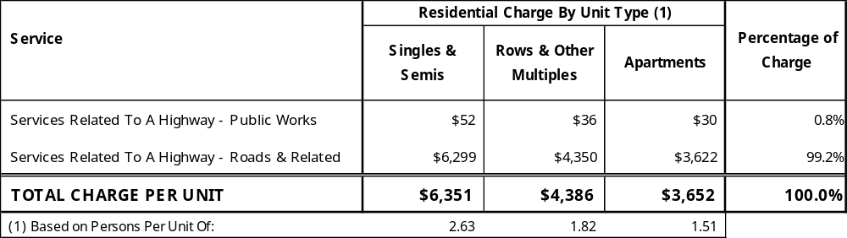

The Corporation of the County of Grey

By-Law 5127-22

Schedule C-1

Non-Residential Development Charges

Effective date: January 1, 2022 to December 31, 2022
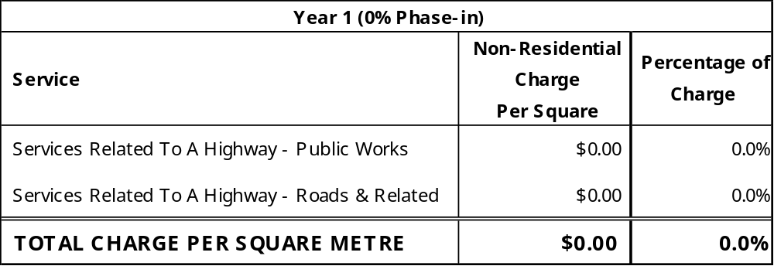

The Corporation of the County of Grey

By-Law 5127-22

Schedule C-2

Non-Residential Development Charges

Effective date: January 1, 2023 to December 31, 2023
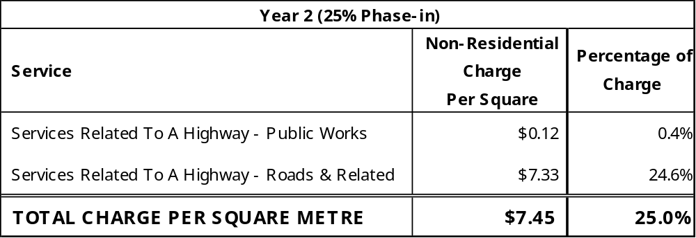

The Corporation of the County of Grey

By-Law 5127-22

Schedule C-3

Non-Residential Development Charges

Effective date: January 1, 2024 to December 31, 2024
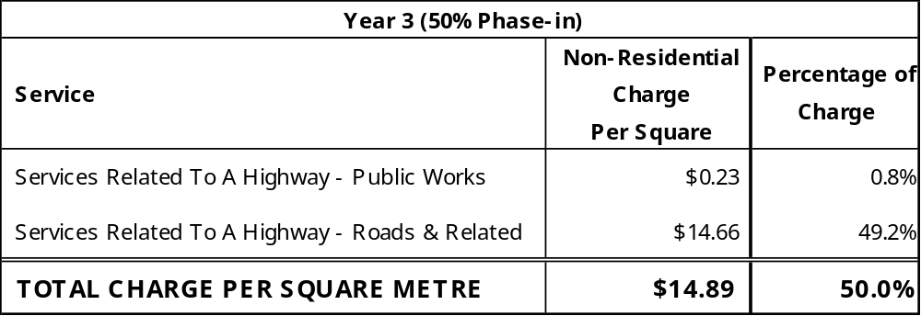

The Corporation of the County of Grey

By-Law 5127-22

Schedule C-4

Non-Residential Development Charges

Effective date: January 1, 2025 to December 31, 2025
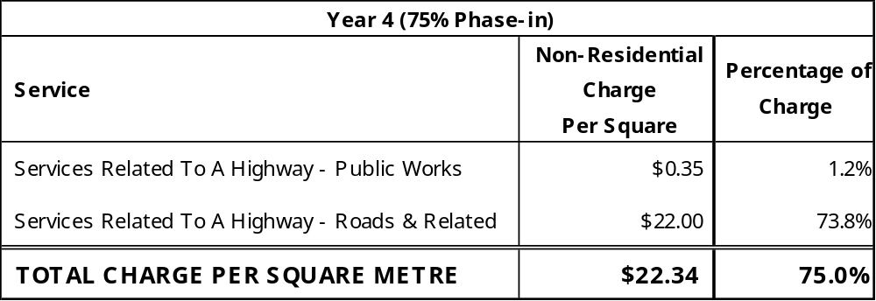

The Corporation of the County of Grey

By-Law 5127-22

Schedule C-5

Non-Residential Development Charges

Effective date: January 1, 2026 to December 31, 2026
